Aesthetic-Usability Effect
Users often perceive aesthetically pleasing design as design that’s more usable.
Users often perceive aesthetically pleasing design as design that’s more usable.
Takeaways
An aesthetically pleasing design creates a positive response in people’s brains and leads them to believe the design actually works better.
People are more tolerant of minor usability issues when the design of a product or service is aesthetically pleasing.
Visually pleasing design can mask usability problems and prevent issues from being discovered during usability testing.
Origins
The aesthetic-usability effect was first studied in the field of human–computer interaction in 1995. Researchers Masaaki Kurosu and Kaori Kashimura from the Hitachi Design Center tested 26 variations of an ATM UI, asking the 252 study participants to rate each design on ease of use, as well as aesthetic appeal. They found a stronger correlation between the participants’ ratings of aesthetic appeal and perceived ease of use than the correlation between their ratings of aesthetic appeal and actual ease of use. Kurosu and Kashimura concluded that users are strongly influenced by the aesthetics of any given interface, even when they try to evaluate the underlying functionality of the system.

Choice Overload
The tendency for people to get overwhelmed when they are presented with a large number of options, often used interchangeably with the term paradox of choice.
The tendency for people to get overwhelmed when they are presented with a large number of options, often used interchangeably with the term paradox of choice.
Choice Overload is a psychology concept closely related to Hick’s Law.

Takeaways
Too many options hurts users’ decision-making ability. How they feel about the experience as a whole can be significantly impacted as a result.
When comparison is necessary, we can avoid choice overload by enabling side-by-side comparison of related items and options that require a decision (e.g. pricing tiers).
We can avoid choice overload by optimizing our designs for the decision-making process and avoid overwhelming users by prioritizing the content that’s shown to them at any given moment (e.g. featured product), providing tools for narrowing down choices up front (e.g. search and filtering).

Chunking
A process by which individual pieces of an information set are broken down and then grouped together in a meaningful whole.
A process by which individual pieces of an information set are broken down and then grouped together in a meaningful whole.
Chunking is a psychology concept closely related to Miller’s Law.

Takeaways
Chunking enables users to easily scan content. It allows them to easily identify the information that aligns with their goals and process that information to achieve their goals more quickly.
Structuring content into visually distinct groups with a clear hierarchy enables designers to align information with how people evaluate and process digital content.
Chunking can be used to help users understand underlying relationships by grouping content into distinctive modules, applying rules to separate content, and providing hierarchy.

Cognitive Bias
A systematic error of thinking or rationality in judgment that influence our perception of the world and our decision-making ability.
A systematic error of thinking or rationality in judgment that influence our perception of the world and our decision-making ability.
Takeaways
Rather than thinking through every situation, we conserve mental energy by developing rules of thumb to make decisions which are based on past experiences. These mental shortcuts increase our efficiency by enabling us to make quick decisions without the need to thoroughly analyze a situation but can also influence our decision-making processes and judgement without our awareness.
Understanding of our own intrinsic biases may not eliminate them completely from our decision-making but it increases the chance that we can identify them in ourselves and others and serve as a safeguard against fallacious reasoning, unintentional discrimination or costly mistakes our decisions.
Take for example our tendency to seek out, interpret, and recall information in a way that confirms their preconceived notions and ideas. This is known as confirmation bias, and it can make having a logical discussion about a polarizing hot-button issue with someone incredibly difficult.

Cognitive Load
The amount of mental resources needed to understand and interact with an interface.
The amount of mental resources needed to understand and interact with an interface.
Cognitive Load is a psychology concept closely related to Miller’s Law.

Takeaways
When the amount of information coming in exceeds the space we have available, we struggle mentally to keep up — tasks become more difficult, details are missed, and we begin to feel overwhelmed.
Intrinsic cognitive load refers to the effort required by users to carry around information relevant to their goal, absorb new information and keep track of their goals.
Extraneous cognitive load refers to the mental processing that takes up resources but doesn't help users understand the content of an interface (e.g. distracting or unnecessary design elements).

Doherty Threshold
Productivity soars when a computer and its users interact at a pace (<400ms) that ensures that neither has to wait on the other.
Productivity soars when a computer and its users interact at a pace (<400ms) that ensures that neither has to wait on the other.
Takeaways
Provide system feedback within 400 ms in order to keep users’ attention and increase productivity.
Use perceived performance to improve response time and reduce the perception of waiting.
Animation is one way to visually engage people while loading or processing is happening in the background.
Progress bars help make wait times tolerable, regardless of their accuracy.
Purposefully adding a delay to a process can actually increase its perceived value and instill a sense of trust, even when the process itself actually takes much less time.

Fitts’s Law
The time to acquire a target is a function of the distance to and size of the target.
The time to acquire a target is a function of the distance to and size of the target.
Takeaways
Touch targets should be large enough for users to accurately select them.
Touch targets should have ample spacing between them.
Touch targets should be placed in areas of an interface that allow them to be easily acquired.

Flow
The mental state in which a person performing some activity is fully immersed in a feeling of energized focus, full involvement, and enjoyment in the process of the activity.
The mental state in which a person performing some activity is fully immersed in a feeling of energized focus, full involvement, and enjoyment in the process of the activity.
Takeaways
Flow occurs when there is a balance between the difficulty of a task with the level of skill at the given task. It’s characterized by intense and focused concentration on the present, combined with a sense of total control.
A task that’s too difficult leads to heighten frustration while a task that’s too easy can lead to boredom. Finding the right balance requires matching the challenge with skill of the user.
Design for flow by providing the necessary feedback so that the user know what action has been done and what has been accomplished.
Optimize for efficiency and system responsiveness by removing any unnecessary friction, and making content and features available for discovery to avoid disengagement with the interface.

Goal-Gradient Effect
The tendency to approach a goal increases with proximity to the goal.
The tendency to approach a goal increases with proximity to the goal.
Takeaways
The closer users are to completing a task, the faster they work towards reaching it.
Providing artificial progress towards a goal will help to ensure users are more likely to have the motivation to complete that task.
Provide a clear indication of progress in order to motivate users to complete tasks.

Hick’s Law
The time it takes to make a decision increases with the number and complexity of choices.
The time it takes to make a decision increases with the number and complexity of choices.
Takeaways
Minimize choices when response times are critical to decrease decision time.
Break complex tasks into smaller steps in order to decrease cognitive load.
Avoid overwhelming users by highlighting recommended options.
Use progressive onboarding to minimize cognitive load for new users.
Be careful not to simplify to the point of abstraction.
Examples

Google Homepage
Google keeps the decisions required to enter a keyword to a minimum by eliminating any additional content that could distract from the act of typing a keyword or require additional decision-making.

Apple TV Remote
Apple TV remotes don’t require a substantial amount of working memory and therefore incurs much less cognitive load. By transferring complexity to the TV interface itself, information can be effectively organized and progressively disclosed within menus.

Slack’s Progressive Onboarding
Instead of dropping users into a fully featured app after enduring a few onboarding slides, Slack uses a bot to engage users and prompt them to learn the messaging feature consequence-free. To prevent new users from feeling overwhelmed, Slack hides all features except for the messaging input. Once users have learned how to message via Slackbot, they are progressively introduced to additional features.

Jakob’s Law
Users spend most of their time on other sites. This means that users prefer your site to work the same way as all the other sites they already know.
Users spend most of their time on other sites. This means that users prefer your site to work the same way as all the other sites they already know.
Takeaways
Users will transfer expectations they have built around one familiar product to another that appears similar.
By leveraging existing mental models, we can create superior user experiences in which the users can focus on their tasks rather than on learning new models.
When making changes, minimize discord by empowering users to continue using a familiar version for a limited time.
Examples

Form Controls
Things like form toggles, radio inputs, and even buttons originated from the design of their tactile counterparts.

YouTube Redesign
When YouTube launched a new version in 2017 after years of essentially the same design, they allowed desktop users to ease into the new Material Design UI without having to commit. Users could preview the new design, gain some familiarity, submit feedback, and even revert to the old version if they preferred it. As a result, the inevitable mental model discordance was avoided by simply empowering users to switch when they were ready.

Law of Common Region
Elements tend to be perceived into groups if they are sharing an area with a clearly defined boundary.
Elements tend to be perceived into groups if they are sharing an area with a clearly defined boundary.
Takeaways
Common region creates a clear structure and helps users quickly and effectively understand the relationship between elements and sections.
Adding a border around an element or group of elements is an easy way to create common region.
Common region can also be created by defining a background behind an element or group of elements.

Law of Proximity
Objects that are near, or proximate to each other, tend to be grouped together.
Objects that are near, or proximate to each other, tend to be grouped together.
Takeaways
Proximity helps to establish a relationship with nearby objects.
Elements in close proximity are perceived to share similar functionality or traits.
Proximity helps users understand and organize information faster and more efficiently.
Examples

Google Search Results
The spacing between each result on Google’s search results page contributes to the overall scannability of the page but also helps to effectively group each result as a related cluster of information.

Law of Prägnanz
People will perceive and interpret ambiguous or complex images as the simplest form possible, because it is the interpretation that requires the least cognitive effort of us.
People will perceive and interpret ambiguous or complex images as the simplest form possible, because it is the interpretation that requires the least cognitive effort of us.
Takeaways
The human eye likes to find simplicity and order in complex shapes because it prevents us from becoming overwhelmed with information.
Research confirms that people are better able to visually process and remember simple figures than complex figures.
The human eye simplifies complex shapes by transforming them into a single, unified shape.

Law of Similarity
The human eye tends to perceive similar elements as a complete picture, shape, or group, even if those elements are separated.
The human eye tends to perceive similar elements as a complete picture, shape, or group, even if those elements are separated.
Takeaways
Elements that are visually similar will be perceived as related.
Color, shape, and size, orientation and movement can signal that elements belong to the same group and likely share a common meaning or functionality.
Ensure that links and navigation systems are visually differentiated from normal text elements.

Law of Uniform Connectedness
Elements that are visually connected are perceived as more related than elements with no connection.
Elements that are visually connected are perceived as more related than elements with no connection.
Takeaways
Group functions of a similar nature so they are visually connected via colors, lines, frames, or other shapes.
Alternately, you can use a tangible connecting reference (line, arrow, etc) from one element to the next to also create a visual connection.
Use uniform connectedness to show context or to emphasize the relationship between similar items.
Examples

Google Search Results
The Law of Uniform Connectedness can be seen within Google’s search results with borders that surrounds specific items such as videos and ‘featured snippets’. This border helps to visually connect the content and also separate it from other results by giving it a bit more priority.

Mental Model
A compressed model based on what we think we know about a system and how it works.
A compressed model based on what we think we know about a system and how it works.
Mental models are a psychology concept closely related to Jakob’s Law.

Takeaways
We form a working model in our minds around what we think we know about a system, especially about how it works, and then we apply that model to new situations where the system is similar.
Match designs to the users’ mental models to improve their experience. This enables them to easily transfer their knowledge from one product or experience to another, without the need to first take the time to understand how the new system works.
Good user experiences are made possible when the design of a product or service is in alignment with the user’s mental model. Take for example e-commerce websites, which use consistent patterns and conventions such product cards, virtual carts and checkout flows in order to conform to users’ expectations.
The task of shrinking the gap between our own mental models and those of the users is one of the biggest challenges we face, and to achieve this goal we use a variety of user research methods (e.g. user interviews, personas, journey maps, empathy maps).

Miller’s Law
The average person can only keep 7 (plus or minus 2) items in their working memory.
The average person can only keep 7 (plus or minus 2) items in their working memory.
Takeaways
Don’t use the “magical number seven” to justify unnecessary design limitations.
Organize content into smaller chunks to help users process, understand, and memorize easily.
Remember that short-term memory capacity will vary per individual, based on their prior knowledge and situational context.
Examples

Chunking
Chunking can organize content to help users process, understand, and memorize easily.

Occam’s Razor
Among competing hypotheses that predict equally well, the one with the fewest assumptions should be selected.
Among competing hypotheses that predict equally well, the one with the fewest assumptions should be selected.
Takeaways
The best method for reducing complexity is to avoid it in the first place.
Analyze each element and remove as many as possible, without compromising the overall function.
Consider completion only when no additional items can be removed.

Paradox of the Active User
Users never read manuals but start using the software immediately.
Users never read manuals but start using the software immediately.
Takeaways
Users are often motivated to complete their immediate tasks and therefore they don't want to spend time up front reading documentation.
This paradox exist because users will save time in the long term if they take the time to optimize the system and learn more about it.
Make guidance accessible throughout the product experience and design it to fit within the context of use so that it can help these active new users no matter what path they choose to take (e.g. tooltips with helpful information).

Pareto Principle
The Pareto principle states that, for many events, roughly 80% of the effects come from 20% of the causes.
The Pareto principle states that, for many events, roughly 80% of the effects come from 20% of the causes.
Takeaways
Inputs and outputs are often not evenly distributed.
A large group may contain only a few meaningful contributors to the desired outcome.
Focus the majority of effort on the areas that will bring the largest benefits to the most users.

Parkinson’s Law
Any task will inflate until all of the available time is spent.
Any task will inflate until all of the available time is spent.
Takeaways
Limit the time it takes to complete a task to what users expect it’ll take.
Reducing the actual duration to complete a task from the expected duration will improve the overall user experience.
Leverage features such as autofill to save the user time when providing critical information within forms. This allows for quick completion of purchases, bookings and other such functions while preventing task inflation.

Peak-End Rule
People judge an experience largely based on how they felt at its peak and at its end, rather than the total sum or average of every moment of the experience.
People judge an experience largely based on how they felt at its peak and at its end, rather than the total sum or average of every moment of the experience.
The Peak-End Rule is a psychology concept closely related to Cognitive Bias.

Takeaways
Pay close attention to the most intense points and the final moments (the “end”) of the user journey.
Identify the moments when your product is most helpful, valuable, or entertaining and design to delight the end user.
Remember that people recall negative experiences more vividly than positive ones.
Examples

Mailchimp
Mailchimp understands this is an important moment, especially for first-time users, so it goes beyond presenting a simple confirmation modal. By infusing a touch of brand character through illustration, subtle animation, and humor, the tool defuses what could potentially be a stressful moment.

Uber
Negative events also provide emotional peaks and can contribute to a user’s lasting impression of an experience. By focusing on people’s perceptions of time and waiting, Uber was able to reduce its post-request cancellation rate and avoid what could easily become a negative emotional peak while using their service.

Postel’s Law
Be liberal in what you accept, and conservative in what you send.
Be liberal in what you accept, and conservative in what you send.
Takeaways
Be empathetic to, flexible about, and tolerant of any of the various actions the user could take or any input they might provide.
Anticipate virtually anything in terms of input, access, and capability while providing a reliable and accessible interface.
The more we can anticipate and plan for in design, the more resilient the design will be.
Accept variable input from users, translating that input to meet your requirements, defining boundaries for input, and providing clear feedback to the user.

Selective Attention
The process of focusing our attention only to a subset of stimuli in an environment — usually those related to our goals.
The process of focusing our attention only to a subset of the stimuli in the environment — usually those related to our goals.
Selective attention is a psychology concept closely related to the Von Restorff Effect.

Takeaways
People often filter out information that isn’t relevant. This happens in order to maintain focus on information that is important or relevant to the task at hand. Designers must guide users’ attention, prevent them from being overwhelmed or distracted, and help them find relevant information or action.
Banner Blindness is an example phenomenon of selection attention where visitors to a website consciously or unconsciously ignore banner-like information. Users have learned to ignore content that resembles ads, is close to ads, or appears in locations traditionally dedicated to ads. Avoid confusion by not styling content to look like ads or placing content and ads in the same visual section.
Change blindness is another example phenomenon of selection attention that occurs when significant changes in an interface go unnoticed because due to the limitations of human attention and the lack of strong cues. Avoid this by analyzing your design for any competing changes that may happen at the same time and that may divert attention from each other.

Serial Position Effect
Users have a propensity to best remember the first and last items in a series.
Users have a propensity to best remember the first and last items in a series.
Takeaways
Placing the least important items in the middle of lists can be helpful because these items tend to be stored less frequently in long-term and working memory.
Positioning key actions on the far left and right within elements such as navigation can increase memorization.

Tesler’s Law
Tesler’s Law, also known as The Law of Conservation of Complexity, states that for any system there is a certain amount of complexity which cannot be reduced.
Tesler’s Law, also known as The Law of Conservation of Complexity, states that for any system there is a certain amount of complexity which cannot be reduced.
Takeaways
All processes have a core of complexity that cannot be designed away and therefore must be assumed by either the system or the user.
Ensure as much as possible of the burden is lifted from users by dealing with inherent complexity during design and development.
Remember to not build products and services for an idealized, rational user, because people don’t always behave rationally in real life.
Make guidance accessible and fit within the context of use so that it can help these active new users, no matter what path they choose to take (e.g., tooltips with helpful information).

Zeigarnik Effect
People remember uncompleted or interrupted tasks better than completed tasks.
People remember uncompleted or interrupted tasks better than completed tasks.
Takeaways
Invite content discovery by providing clear signifiers of additional content.
Providing artificial progress towards a goal will help to ensure users are more likely to have the motivation to complete that task.
Provide a clear indication of progress in order to motivate users to complete tasks.

Von Restorff Effect
The Von Restorff effect, also known as The Isolation Effect, predicts that when multiple similar objects are present, the one that differs from the rest is most likely to be remembered.
Von Restorff Effect
The Von Restorff effect, also known as The Isolation Effect, predicts that when multiple similar objects are present, the one that differs from the rest is most likely to be remembered.
The Von Restorff effect, also known as The Isolation Effect, predicts that when multiple similar objects are present, the one that differs from the rest is most likely to be remembered.
Takeaways
Make important information or key actions visually distinctive.
Use restraint when placing emphasis on visual elements to avoid them competing with one another and to ensure salient items don’t get mistakenly identified as ads.
Don’t exclude those with a color vision deficiency or low vision by relying exclusively on color to communicate contrast.
Carefully consider users with motion sensitivity when using motion to communicate contrast.

Working Memory
A cognitive system that temporarily holds and manipulates information needed to complete tasks.
Working Memory
A cognitive system that temporarily holds and manipulates information needed to complete tasks.
A cognitive system that temporarily holds and manipulates information needed to complete tasks.
Working memory is a psychology concept closely related to cognitive load.

Takeaways
Working memory is limited to 4-7 chunks of information at any given moment with each chunk fades after 20-30 seconds. We use it to keep track of information in order to achieve tasks but we often have trouble remembering what information we’ve already seen. Designers must be mindful of this limit when displaying information to users and ensure it’s both necessary and relevant.
Our brains are good at recognizing something we’ve seen before but not at keeping new information ready to be used. We can support recognition over recall by making it clear what information has already been viewed (e.g. visually differentiating visited links and providing breadcrumbs links).
Place burden of memory on the system, not the user. We can lessen the burden of memorizing critical information by carrying it over from screen to screen when necessary (e.g. comparison tables that make comparing multiple items easy).

Design principles
Explore fundamental principles that guide design across Apple platforms.
The most successful and enduring designs are based on a deep understanding of how people think, feel, and interact with the world. The principles here reflect this reality, and form the foundation for guidance throughout the Human Interface Guidelines. There’s no one right way to apply these principles. Instead, they’re tools to help you weigh competing priorities and make key decisions on the path to a great design.

Purpose
Make something meaningful.

Design starts with intention. Identify what matters most to the people you’re designing for. Focus on making those things great, and you’ll create an experience that people truly value.

Agency
Let people do things their own way.

An interface exists to help people accomplish their goals. Give them the freedom to act, keep them informed about what’s happening, and make it easy to recover from mistakes.

Responsibility
Act in people’s best interest.

Your work has an impact on people’s lives. Earn their trust by prioritizing safety and privacy, and being transparent about what your product does and why.

Familiarity
Build on what people know.

Drawing on concepts people already understand helps them feel immediately at home. Ground your experience in established physical and digital patterns and apply them consistently throughout your design.

Flexibility
Adapt to diverse contexts and needs.

People use your software in ways as unique as they are. The more your design acknowledges this, the more people feel welcome to use it. Be mindful of experiences other than yours, and try to support as many devices, types of interaction, and perspectives as possible.

Simplicity
Be clear and direct.

A well-designed experience removes the unnecessary, with every element earning its place. When your interface is logically organized and straightforward to navigate, it’s easier to get things done.

Craft
Care about every detail.

Your design is a reflection of how much you care. It shows your dedication to delivering the best possible experience for people. Take the time to do the work well.

Delight
Make it human.

People remember how a product makes them feel. Think about the emotions that are right for your experience, and aim to deliver them in a way that’s satisfying, enriching, and a joy to use.

Purpose
Create value. The best designs reflect a constant orientation toward what makes a product genuinely useful. At every stage of development, ask what your product is for and whether the design serves that purpose.

Keep focused. Prioritize your app’s most important features by aligning with how people want to use it, and focus on making those features truly great. A product with a clear use is more effective at helping people meet their goals.

Find new ways to solve the problem. Investigate existing solutions, and avoid re-creating them. Define what sets your product apart, and ask how your design can reflect that.

Agency
Stay out of the way. People use your product to get things done. Often the best way to help them do this is to get them directly to the task or content at hand. The best designs are unobtrusive and present when people need them.

Give people the freedom to explore. Let them move through your interface and access features without being locked into specific flows or modes. When a guided flow is necessary, make it easy to skip or escape so people can get to the main experience quickly.

Help people recover from mistakes. When people know they can reverse an action or return to a previous state, they feel free to explore, and that freedom makes your interface more inviting. Build forgiveness into your design, and make it easy. Recovering from the unexpected shouldn’t cost people their time or work.

Responsibility
Be fully transparent about what your product does and why. You have an opportunity to build a relationship with someone from their very first interaction. Make sure your app’s intentions are clear from the start. Provide a clear rationale when asking for permission, and when gathering data, be clear about what you collect and how you use it.

Keep people’s information safe. People trust you to maintain the integrity of their data. Only collect what your product needs to function, and handle it with care. Anticipate ways it could be misused or cause harm, and put protections in place to prevent abuse and unintended consequences.

Familiarity
Use concepts that people know. People bring knowledge of the real world and other software to every new experience. Draw on both to make your interface feel familiar and intuitive.

Keep visuals and interactions consistent. Once you establish a behavior or appearance for an element, apply it throughout your design. Consistency helps people learn more quickly, and gives them confidence that new interactions will work the way they expect.

Provide clear feedback. Give people clear signals about what’s happening as they use your app. Show when controls are available, indicate when content changes, and use system patterns to display alerts and offer choices. Consistent feedback helps keep people informed and in control.

Flexibility
Design for everyone. People are empowered by products designed with them in mind. Think about the diversity of people who may encounter your design, and take the range of their experiences, perspectives, and needs into account. Treat accessibility as a priority from the start. Design inclusively to reach the broadest possible audience and create a better experience for all.

Preserve a person’s context. Help people feel at home as your design adapts across platforms and configurations. Keep content and controls in consistent, predictable positions, and use natural animations to ease transitions.

Consider a variety of input methods. People interact with their devices in different ways. Designing for as many inputs as possible — including voice, touch, keyboard, and more — means more people can use your product the way that works best for them.

Approach every platform with intention. Your software should feel polished and at home wherever it runs. Give each platform you support the same level of care.

Simplicity
Include just what’s necessary. Simplicity isn’t minimalism. Aim for a focused, useful experience that keeps the important things close by and lets the others fall away.

Be concise. When you find the simplest way to say something, it’s often the most universal, and the most helpful. Choose exactly the words you need to convey a concept or label a control.

Establish hierarchy. When form and function are readily apparent, people know how to reach a desired outcome. Prioritize recognizable controls and a consistent structure that helps people understand where they are and what comes next.

Craft
Quality sets the tone. Every element of your design shows people how much you care. Be deliberate with each decision, and strive for stunning visuals, smooth animations, precise wording, and thoughtful audio.

Experiment and iterate. Prototype early, try new approaches, and be willing to discard what doesn’t work. Set a high bar for every feature, refine it, and try again. Test your product in real-world settings to make sure it’s durable, reliable, and high-performing.

Maintain your craft. Shipping isn’t the finish line. Keep your interface current with the latest platform capabilities and design patterns, and keep the quality bar high. Design is an ongoing commitment.

Delight
Identify the emotion you want to inspire. Not all software feels the same to use. A fitness app might energize; a meditation app might calm; a game might thrill. Know the feeling you want to evoke, and let it shape your design.

Create defining moments. Every interaction is a chance to show what your software stands for. From a simple button press to an error message, consider whether each moment is an opportunity to add a touch of character that reflects the spirit of your design.

Don’t mistake delight for decoration. Keep in mind that people are trying to accomplish a task, so don’t let pursuit of delight for its own sake get in the way of your product’s core purpose. Think about your overall aesthetic: Some designs benefit from a carefully considered practical touch, while others might prefer some whimsy. Experiment to find the right balance.

Consider the whole. Delight emerges as the sum of the consideration that you put into your product. It’s the culmination of everything a person experiences as they use it: the freedom to act, the safety to explore, the comfort of familiar metaphors, and the flexibility to transition from one context to another. When you design with intent, focus, and care, the result is a product that people find naturally delightful.

Designing for iPadOS
People value the power, mobility, and flexibility of iPad as they enjoy media, play games, perform detailed productivity tasks, and bring their creations to life.

As you begin designing your app or game for iPad, start by understanding the following fundamental device characteristics and patterns that distinguish the iPadOS experience. Using these characteristics and patterns to inform your design decisions can help you provide an app or game that iPad users appreciate.

Display. iPad has a large, high-resolution display.

Ergonomics. People often hold their iPad while using it, but they might also set it on a surface or place it on a stand. Positioning the device in different ways can change the viewing distance, although people are typically within about 3 feet of the device as they interact with it.

Inputs. People can interact with iPad using Multi-Touch gestures and virtual keyboards, an attached keyboard or pointing device, Apple Pencil, or voice, and they often combine multiple input modes.

App interactions. Sometimes, people perform a few quick actions on their iPad. At other times, they spend hours immersed in games, media, content creation, or productivity tasks. People frequently have multiple apps open at the same time, and they appreciate viewing more than one app onscreen at once and taking advantage of inter-app capabilities like drag and drop.

System features. iPadOS provides several features that help people interact with the system and their apps in familiar, consistent ways.

Multitasking

Widgets

Drag and drop

Best practices
Great iPad experiences integrate the platform and device capabilities that people value most. To help your experience feel at home in iPadOS, prioritize the following ways to incorporate these features and capabilities.

Take advantage of the large display to elevate the content people care about, minimizing modal interfaces and full-screen transitions, and positioning onscreen controls where they’re easy to reach, but not in the way.

Use viewing distance and input mode to help you determine the size and density of the onscreen content you display.

Let people use Multi-Touch gestures, a physical keyboard or trackpad, or Apple Pencil, and consider supporting unique interactions that combine multiple input modes.

Adapt seamlessly to appearance changes — like device orientation, multitasking modes, Dark Mode, and Dynamic Type — and transition effortlessly to running in macOS, letting people choose the configurations that work best for them.

Designing for iOS
People depend on their iPhone to help them stay connected, play games, view media, accomplish tasks, and track personal data in any location and while on the go.

As you begin designing your app or game for iOS, start by understanding the following fundamental device characteristics and patterns that distinguish the iOS experience. Using these characteristics and patterns to inform your design decisions can help you provide an app or game that iPhone users appreciate.

Display. iPhone has a medium-size, high-resolution display.

Ergonomics. People generally hold their iPhone in one or both hands as they interact with it, switching between landscape and portrait orientations as needed. While people are interacting with the device, their viewing distance tends to be no more than a foot or two.

Inputs. Multi-Touch gestures, virtual keyboards, and voice control let people perform actions and accomplish meaningful tasks while they’re on the go. In addition, people often want apps to use their personal data and input from the device’s gyroscope and accelerometer, and they may also want to participate in spatial interactions.

App interactions. Sometimes, people spend just a minute or two checking on event or social media updates, tracking data, or sending messages. At other times, people can spend an hour or more browsing the web, playing games, or enjoying media. People typically have multiple apps open at the same time, and they appreciate switching frequently among them.

System features. iOS provides several features that help people interact with the system and their apps in familiar, consistent ways.

Widgets

Home Screen quick actions

Spotlight

Shortcuts

Activity views

Best practices
Great iPhone experiences integrate the platform and device capabilities that people value most. To help your design feel at home in iOS, prioritize the following ways to incorporate these features and capabilities.

Help people concentrate on primary tasks and content by limiting the number of onscreen controls while making secondary details and actions discoverable with minimal interaction.

Adapt seamlessly to appearance changes — like device orientation, Dark Mode, and Dynamic Type — letting people choose the configurations that work best for them.

Support interactions that accommodate the way people usually hold their device. For example, it tends to be easier and more comfortable for people to reach a control when it’s located in the middle or bottom area of the display, so it’s especially important let people swipe to navigate back or initiate actions in a list row.

With people’s permission, integrate information available through platform capabilities in ways that enhance the experience without asking people to enter data. For example, you might accept payments, provide security through biometric authentication, or offer features that use the device’s location.

Designing for macOS
People rely on the power, spaciousness, and flexibility of a Mac as they perform in-depth productivity tasks, view media or content, and play games, often using several apps at once.

As you begin designing your app or game for macOS, start by understanding the fundamental device characteristics and patterns that distinguish the macOS experience. Using these characteristics and patterns to inform your design decisions can help you provide an app or game that Mac users appreciate.

Display. A Mac typically has a large, high-resolution display, and people can extend their workspace by connecting additional displays, including their iPad.

Ergonomics. People generally use a Mac while they’re stationary, often placing the device on a desk or table. In the typical use case, the viewing distance can range from about 1 to 3 feet.

Inputs. People expect to enter data and control the interface using any combination of input modes, such as physical Keyboards, Pointing devices, Game controls, and Siri.

App interactions. Interactions can last anywhere from a few minutes of performing some quick tasks to several hours of deep concentration. People frequently have multiple apps open at the same time, and they expect smooth transitions between active and inactive states as they switch from one app to another.

System features. macOS provides several features that help people interact with the system and their apps in familiar, consistent ways.

The menu bar

File management

Going full screen

Dock menus

Best practices
Great Mac experiences integrate the platform and device capabilities that people value most. To help your design feel at home in macOS, prioritize the following ways to incorporate these features and capabilities.

Leverage large displays to present more content in fewer nested levels and with less need for modality, while maintaining a comfortable information density that doesn’t make people strain to view the content they want.

Let people resize, hide, show, and move your windows to fit their work style and device configuration, and support full-screen mode to offer a distraction-free context.

Use the menu bar to give people easy access to all the commands they need to do things in your app.

Help people take advantage of high-precision input modes to perform pixel-perfect selections and edits.

Handle keyboard shortcuts to help people accelerate actions and use keyboard-only work styles.

Support personalization, letting people customize toolbars, configure windows to display the views they use most, and choose the colors and fonts they want to see in the interface.

What are web design principles?
Web design principles are reusable rules and guidelines that shape the site's layout, interaction, content, and accessibility. They help you follow a consistent framework that ensures positive user experiences by guiding the use of patterns and components.
If this terminology sounds a bit confusing, here's a quick table that clarifies the key terms:
Term | What it is | Example
Principle | A general rule that guides design decisions | "Prioritize one primary action per screen."
Pattern | A solution template or proven way to solve a recurring problem | “Account creation with email + magic link.”
Component | A reusable component or styled building block | “Primary Button/ButtonGroup/Card.”
Each principle aims to achieve a specific goal that contributes to a positive user experience.
Let's take visual hierarchy as an example. In most cases, following this principle solves the problem of a cluttered homepage. Here's a before-and-after scenario that shows the results of hierarchy implementation:
- Before: The homepage shows a rotating carousel, four equal “Learn more/Shop/Subscribe/Contact” buttons, three promo banners, and a newsletter modal on load. All CTAs look identical; headings are the same size, spacing is tight, and users miss the main action (start shopping).
- After:
  - Define one primary goal: “Start shopping.”
  - Replace the carousel with a hero section: H1 “Fresh groceries, delivered today,” short subcopy, and one filled primary button “Start shopping.”
  - Demote secondary actions to text links in the header and a ButtonGroup with outline styles below the fold.
  - Group promos into a 3-card grid under “Popular this week,” each with a single secondary CTA.
  - Increase hierarchy via type scale (H1 36–40 px, H2 24–28 px, body 16 px), 8-pt spacing rhythm, and contrast(AA-compliant).
Whether you're creating a new site or refreshing an existing one, well-defined principles will help designers and product teams align scope, decisions, and success metrics.

Why do website design principles matter?
Website design principles reduce rework by creating a common decision framework across design, product, engineering, and content.
Instead of going back and forth on every screen, teams can repeatedly reference specific rules (e.g., “one primary action per page” or “write task-first headings”). This results in:
- Streamlined design workflows
- Fewer late-stage changes
- Consistency in UI, copy, and code
Seeing as each principle serves a specific goal, it can be tied to a concrete outcome you can measure. For example:
- Visual hierarchy → clear focus on the next step → increased CTA click-through rate
- Contrast and readability → easier to read and fill forms → improved form completion rate
- Clear navigation → users find tasks faster → shorter median time to task
Another reason to define and follow clear design principles is to ensure inclusivity and compliance with best practices and legal requirements.
Principles like sufficient color contrast, semantic structure, and keyboard operability directly map to Web Content Accessibility Guidelines (WCAG) 2x success criteria, so applying them improves accessibility for:
- Screen-reader users
- Low-vision users
- Visitors with motor or cognitive disabilities
At the same time, doing so minimizes the risk of non-compliance with important accessibility laws and directives (e.g., ADA, Equality Act, EU Web Accessibility Directive).
Not following the necessary principles doesn't only result in the absence of these benefits—it can expose you to many risks, such as:
- Inconsistent, hard-to-maintain site: One-off decisions proliferate, causing duplicate components, conflicting behaviors, and costly rework.
- Brand dilution and trust erosion: Inconsistent visuals, tone, and interaction behaviors make the site feel unreliable, lowering perceived quality and willingness to take action.
Use in practice:
- Choose principles: Hierarchy, clarity, consistency, feedback, accessibility, etc. Define each with a one-line rule and a “when it applies” note.
- Codify in docs: Put principles in your design system with examples, do/don’t visuals, copy guidelines, and WCAG mappings; add metrics you’ll track per principle.
- Review in crits/QA: Turn principles into checklist items for design crits, content reviews, code reviews, and release QA

19 website design principles to follow
To create web pages that provide users with a pleasant experience, follow these principles:

1. Clarity and simplicity
Cluttered web pages confuse users and cause distractions that pull them away from the page's focus and intended action. Simplifying the interface reduces noise so that attention flows to the key tasks you want the user to accomplish.
There are many reasons why your page might be cluttered, but extensive text is often the main culprit. While there's a time and place for text-rich pages (e.g., blog posts), you shouldn't meet the user with huge blocks of text.
Instead, keep your copy as punchy as possible. This way, a sentence like:
"If you're looking for a graphic design agency, you've come to the right place—we will help you design unique visual materials that establish a consistent brand presence and make your business stand out in the crowd."
Can become:
"Our agency translates ideas into compelling visual forms to establish a unique brand identity."
In my experience, the first copy draft will probably have to be trimmed down a few times before you land on the final version. Revisit your copy to spot and remove any fluff.
Other effective ways to simplify a page include:
- Reducing actions and buttons: Make sure there's one primary CTA per view. Turn secondary actions into links or move them to a details panel.
- Limiting color palettes: Stick to a single color palette that reflects your brand visuals. Make sure there's enough contrast between the background and the page's content (especially CTAs and important buttons).
- Simplifying typography: Use 1–2 typefaces and a clear scale (e.g., 12–16–20–28 px) to avoid messy and cluttered typography
Pro tip: Use white space as a feature, not a leftover. It creates visual breathing room, groups related elements, and points the eye to what matters. More often than not, increasing spacing and reducing borders does more for clarity than adding lines or boxes.
If you need an example of a simple but captivating page design, look at Squarespace's homepage:
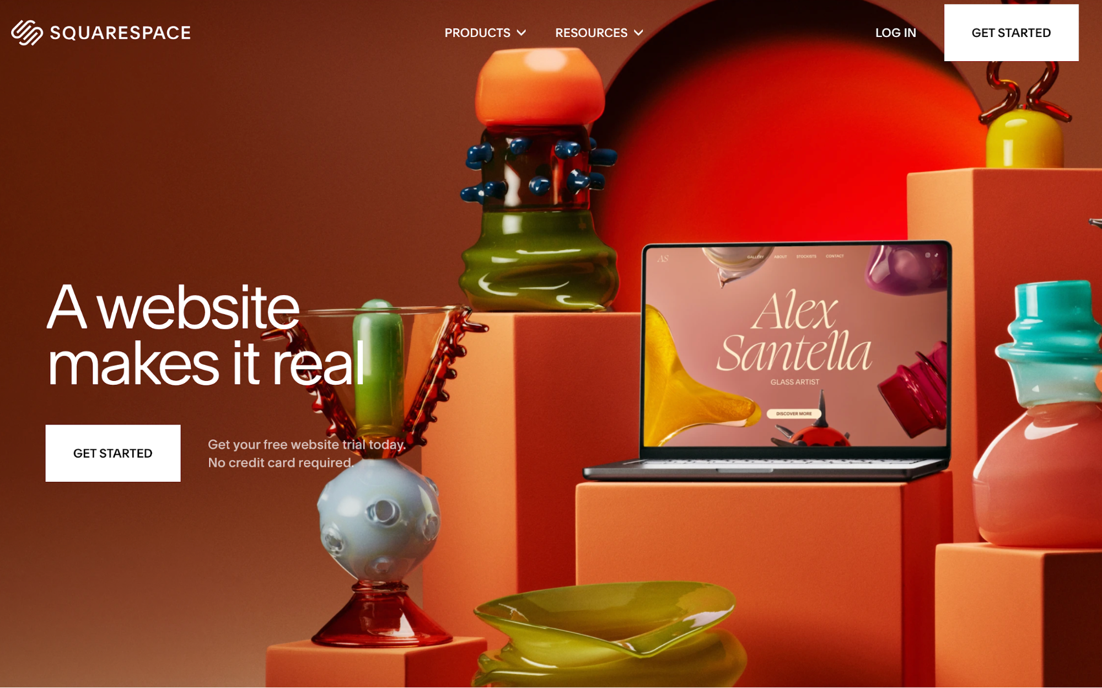
The target action is clear (getting started), and everything on the page supports it, from crisp copy to the contrast between a vibrant background and white CTA buttons.
The page also proves that white space doesn't actually need to be white—you're free to add some splash of color as long as the content is contrasted well.

2. Visual hierarchy
Visual hierarchy prevents users from being overwhelmed by guiding their attention through the size, color, contrast, and placement of different components. It also makes navigation intuitive and helps users take action more smoothly.
The easiest way to achieve a clear hierarchy is to use the H1 → H2 → body → CTA structure while paying attention to the elements like color and size. Here's a sample hero layout you can follow:
- H1 (largest, bold): 40–56 px desktop; concise value prop (“Do X better/faster”).
- H2/subhead (medium, regular): 20–24 px; one sentence that clarifies the promise.
- Body (regular): 16–18 px; 1–2 lines to reduce uncertainty (what it is, who it’s for).
- Primary CTA (high contrast): Prominent button (“Get started” / “Start free trial”).
- Placement: H1 top-left; subhead immediately below; CTA under the copy (or right-aligned in the same block). Keep a single visual (product shot/illustration) adjacent, not competing.
If you want to see this layout in action, Stripe's homepage follows it:
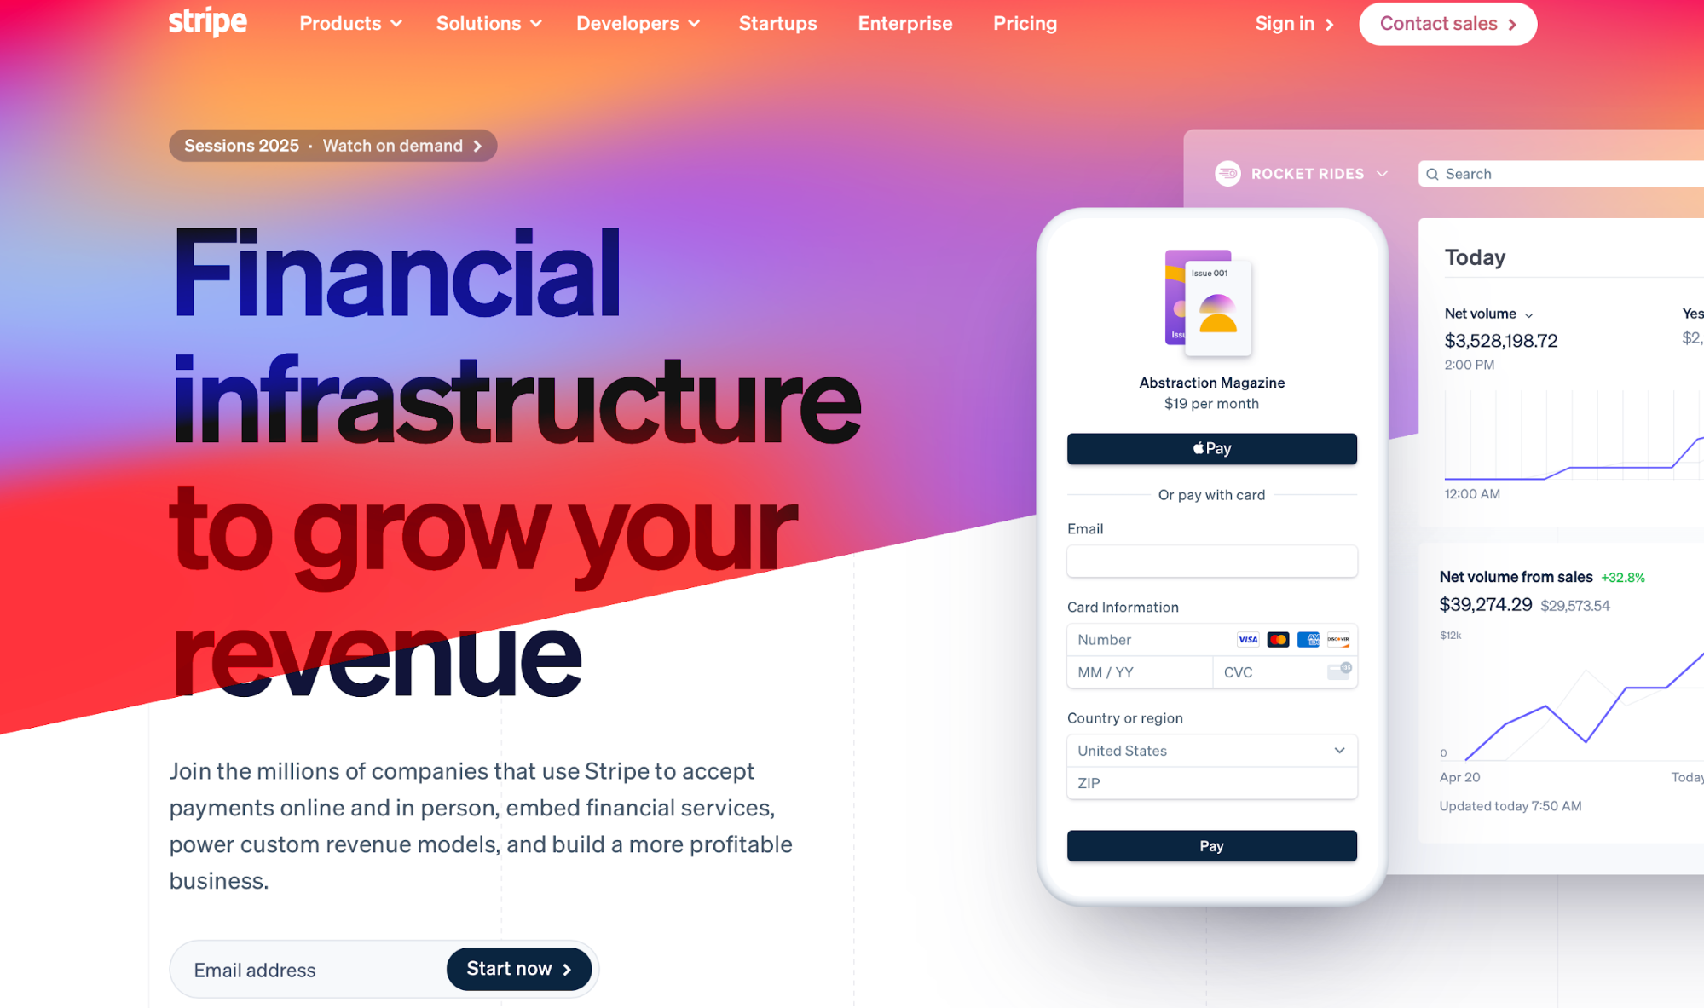
The eye is immediately drawn to the H1 and intuitively guided to the CTA without confusion or overwhelm.
Now let's contrast this to a page like Gates N Fences:
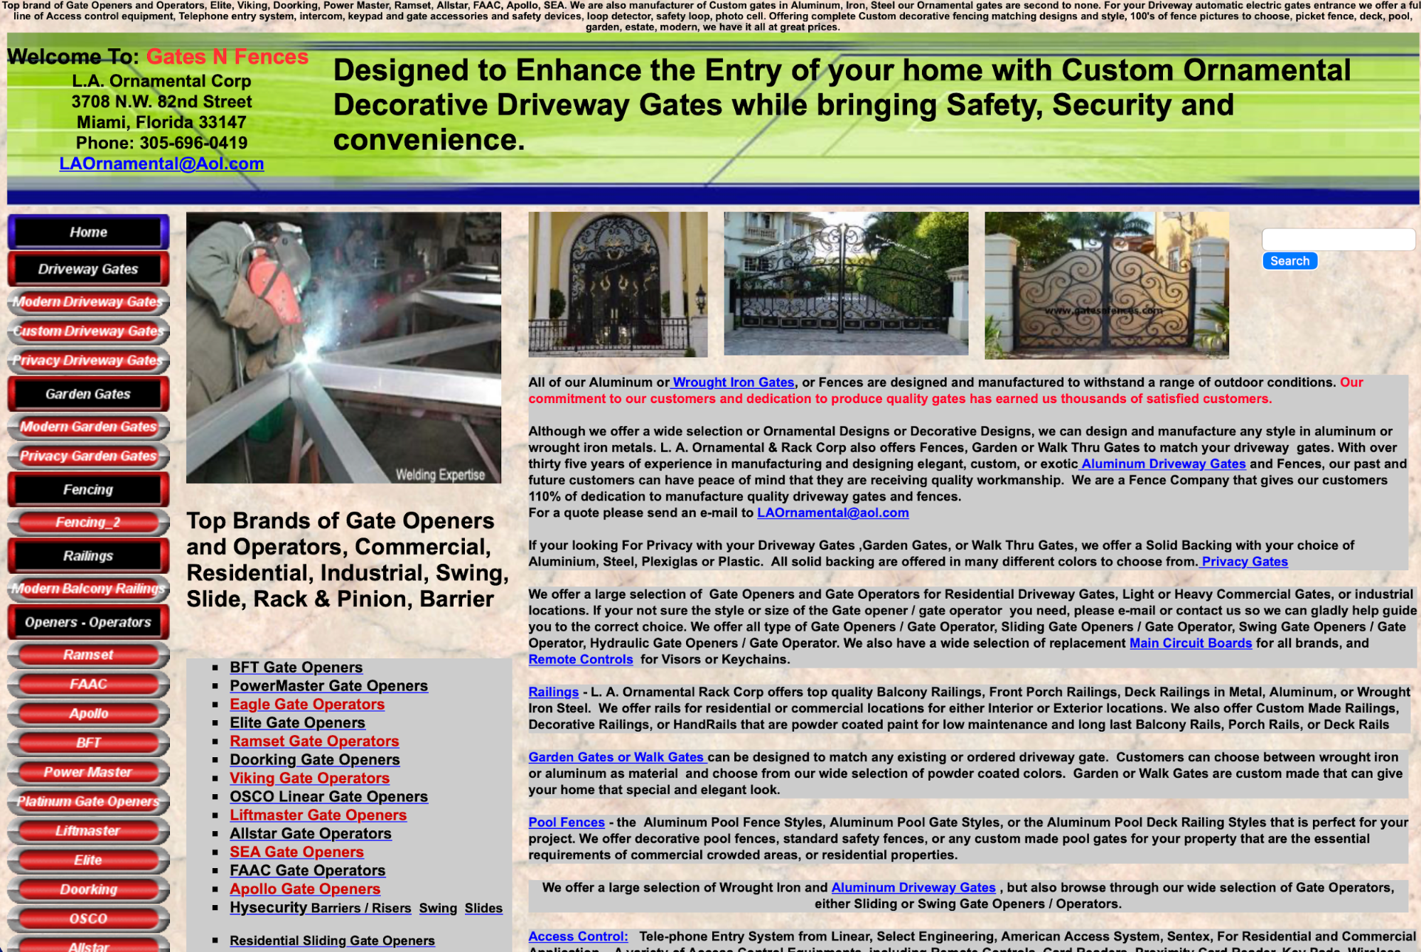
You can instantly see why this page is tough on the eyes.
There's no clear entry point for the eye, and the page piles dense text, huge link lists, mixed font sizes, and competing sections with little spacing. As you enter the page, you start haphazardly scanning it without clarity on the next step.

3. Navigation
Besides being esthetically pleasing, your website needs to ensure streamlined navigation. You should strike the right balance between looks and functionality, which you can do by following a few simple rules.
First, map your site's navigation by splitting it into two types:
- Primary navigation: Include 5–7 top-level items, which outline the core tasks you want users to complete on the site (e.g., Products, Pricing, Docs, etc.).
- Secondary navigation: Dedicate secondary navigation to utilities, which should be clearly separated from primary items.
If this sounds a bit abstract, here's an example of Samsung's homepage:
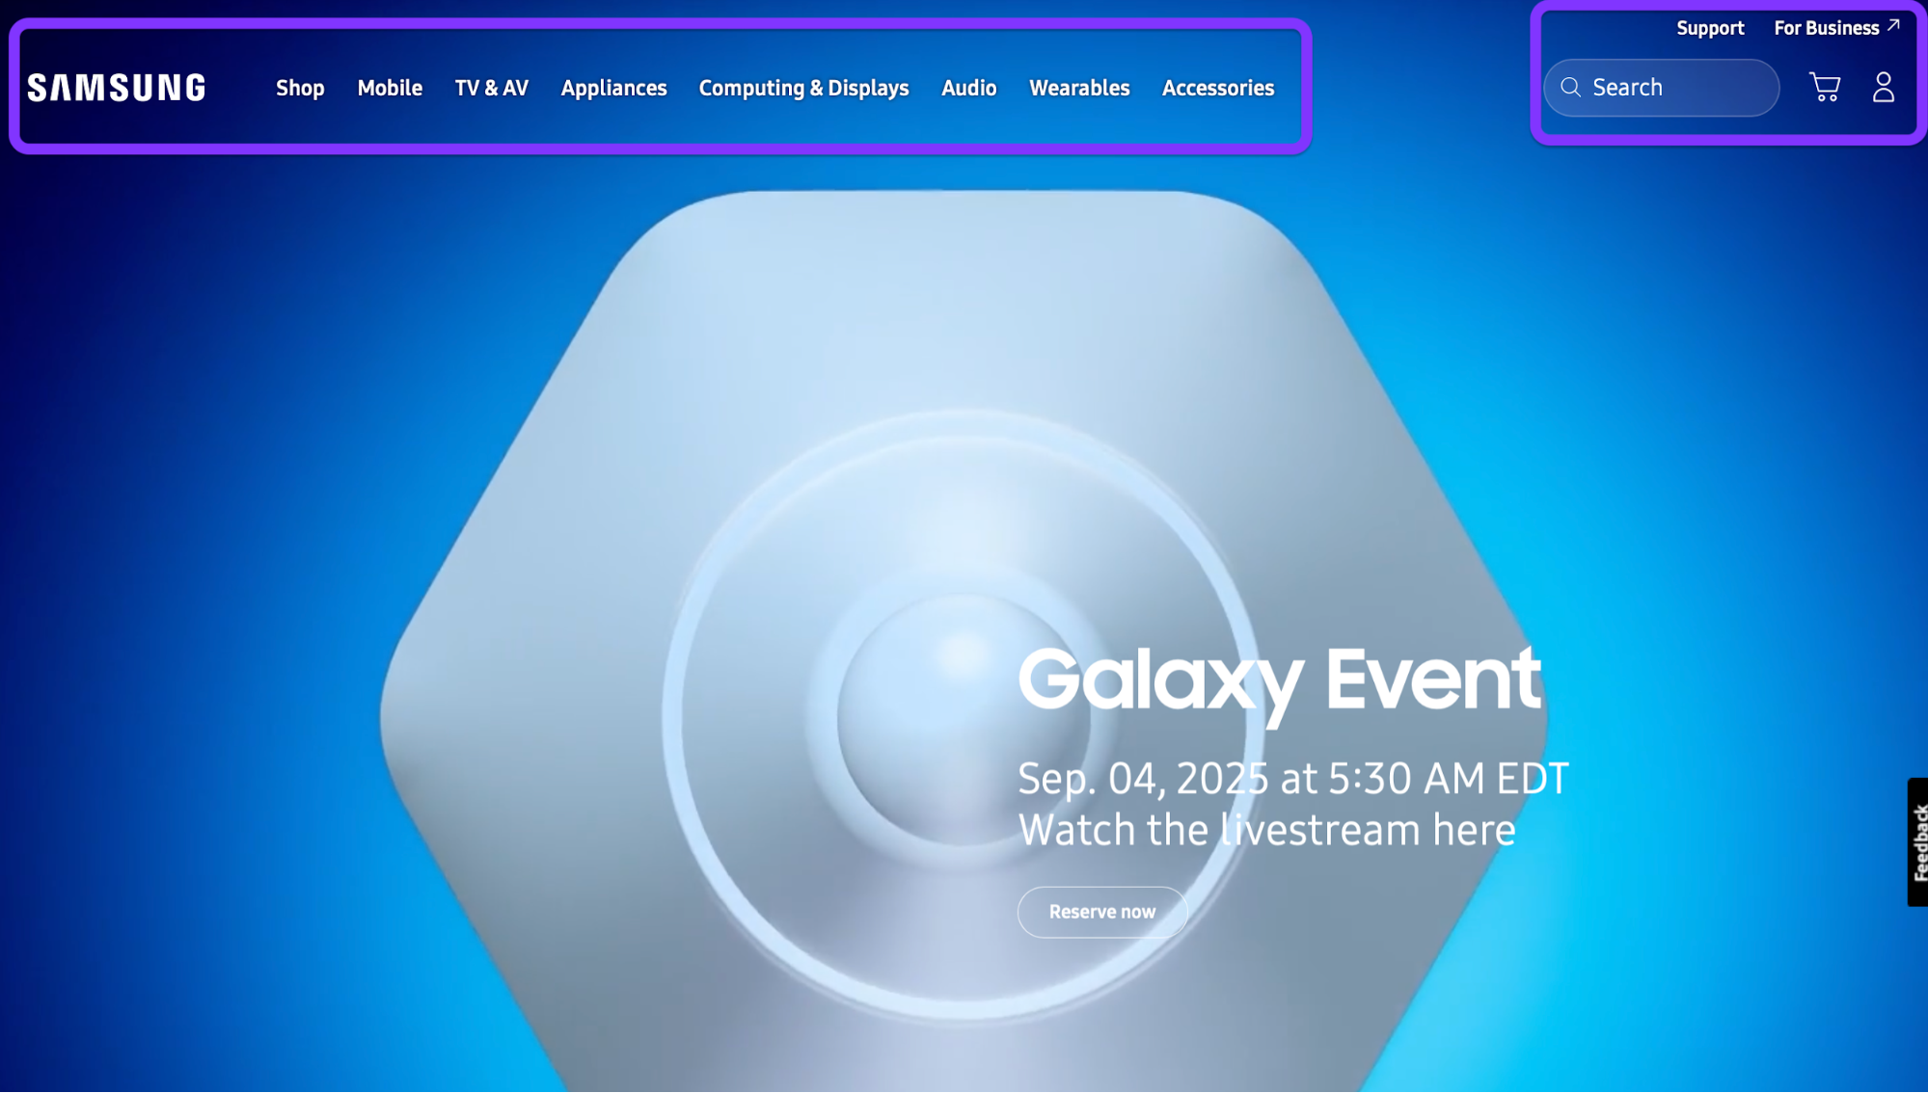
As you can see, there are two distinct categories of items—one for core tasks and another for utilities like search, support, and account creation.
You also don't want to make users dig too deep to find what they need and complete the key tasks. Instead, make sure the user can access them in no more than two clicks (e.g., Home → Section → Target page).
If a task consistently needs 3+ clicks, promote it in the information architecture (IA) or surface it as a quick link.
Of course, not all of your website will be accessible in two clicks. You'll most likely have three or more levels, in which case you should use breadcrumbs (e.g., Home > Products > Analytics > Dashboards). When setting them up, follow these rules:
- Make all but the last item clickable
- Mirror real labels (page names)
- Keep breadcrumbs directly under the header for quick backtracking and orientation
And if you struggle to keep the key actions close to the entry point, try rethinking your labels. For example, you can split a catch-all dropdown label like Solutions into concrete, task-first labels like Use cases, Templates, and Integrations.
Doing so improves information scent and speed scanning, making tasks more visible and accessible.
To validate your navigation and its effectiveness, you can use two types of tests:
- Card sort (30–45 min): List ~20 common topics on cards, and then ask 5–8 users to group and name them. Use the winning group names as candidate top-level labels.
- Tree test (30 min): Paste a text-only version of your nav into a tree-testing tool or a spreadsheet outline and give 5–8 tasks (“Find pricing for Team plan”). Track success rate and time-to-first-click, fixing anything below ~80% success.

4. Grid‑based layout
A grid-based layout gives your page a consistent rhythm and alignment, so users can scan it faster and find what they need with less cognitive load.
Columns and gutters create predictable “parking spots” for content (cards, images, forms) that line up across pages and breakpoints, ensuring a clean and responsive design.
Start with a 12-column grid on desktop. Give yourself 24 px gutters between columns and 32–40 px outer margins inside the page container (a comfy 1200–1280 px max width works well).
This setup works because 12 divides nicely into 2, 3, 4, and 6, so you can make halves, thirds, and quarters without wobbly spacing.
As the screen size drops, the grid should shrink:
- Desktop (≥1200 px): 12 columns, 24 px gutters, 32–40 px margins
- Tablet (768–1199 px): 8 columns, 20 px gutters, 24–32 px margins
- Phone (≤767 px): 4 columns, 16 px gutters, 16–24 px margins
To visualize this structure, picture a row of content cards (image, title, meta, CTA) like a blog or product grid.
- On desktop, place three cards per row at 4/12 columns each (4 + 4 + 4). All card edges line up, images share a top baseline, and CTAs sit on the same vertical step (use an 8-pt spacing scale so paddings/margins are 8/16/24/32 px, etc.).
- On tablet, shift to two cards per row, each 4/8 columns.
- On phone, go one card per row, a full 4/4 columns, stacking image → text → CTA.
If you need a practical example, you can check out Intercom's help center. On desktop, you can see a 3-column card layout for collections:
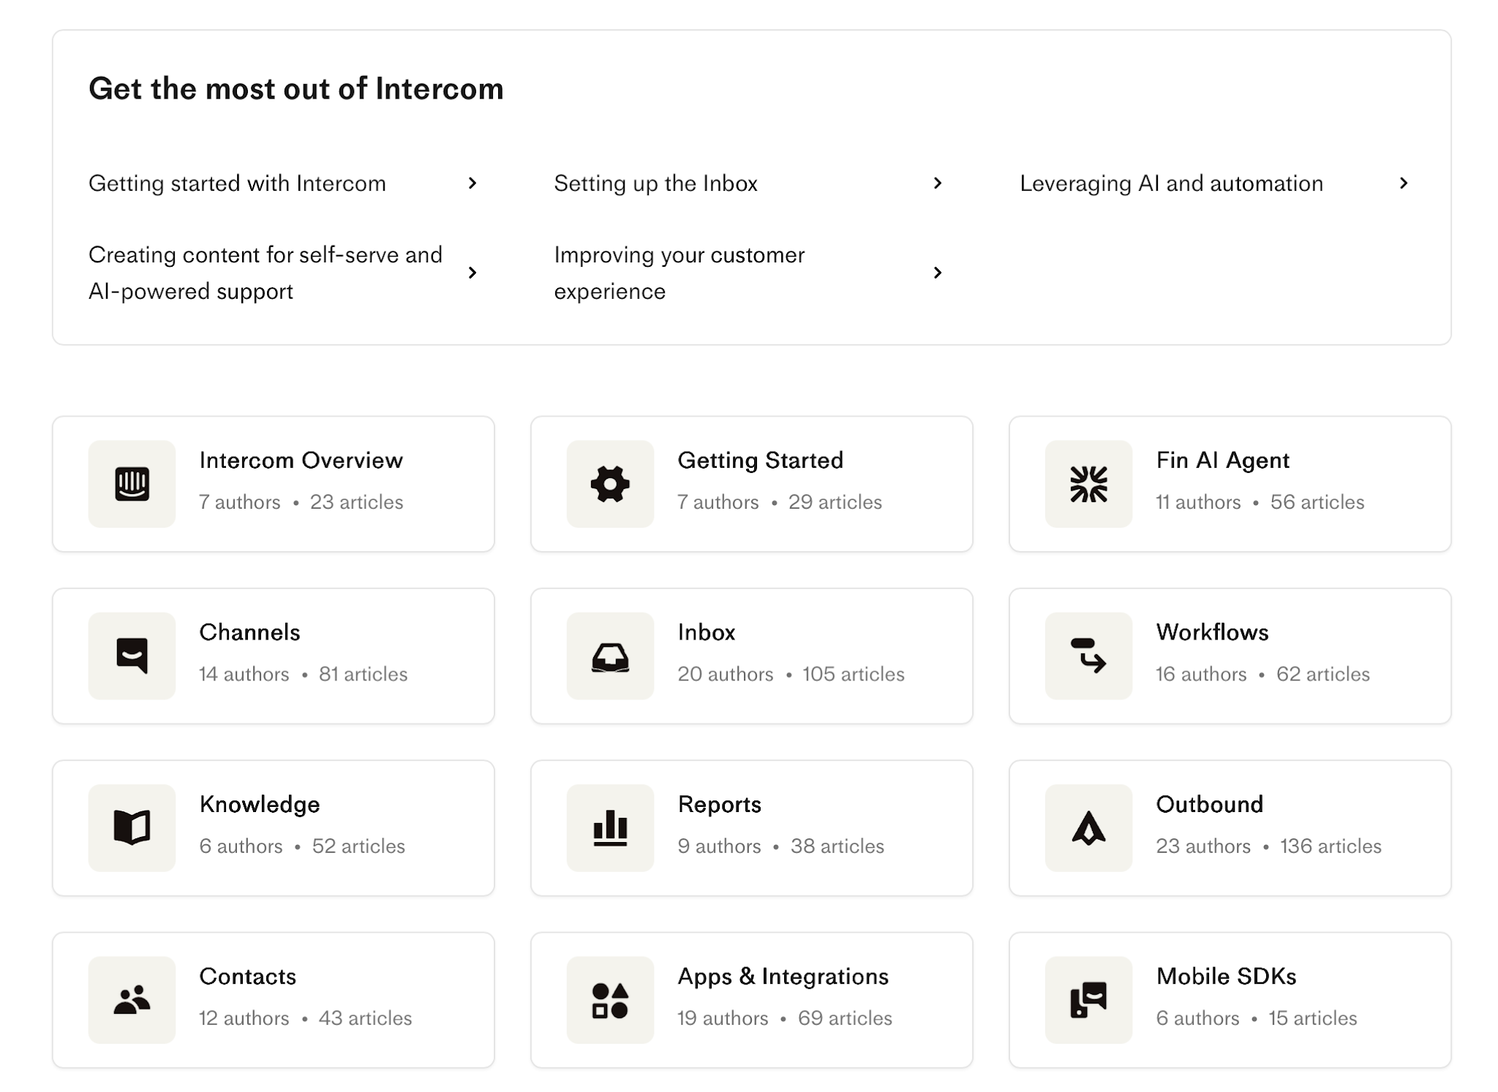
When you switch to mobile, the collection cards collapse down to a 1-column layout:
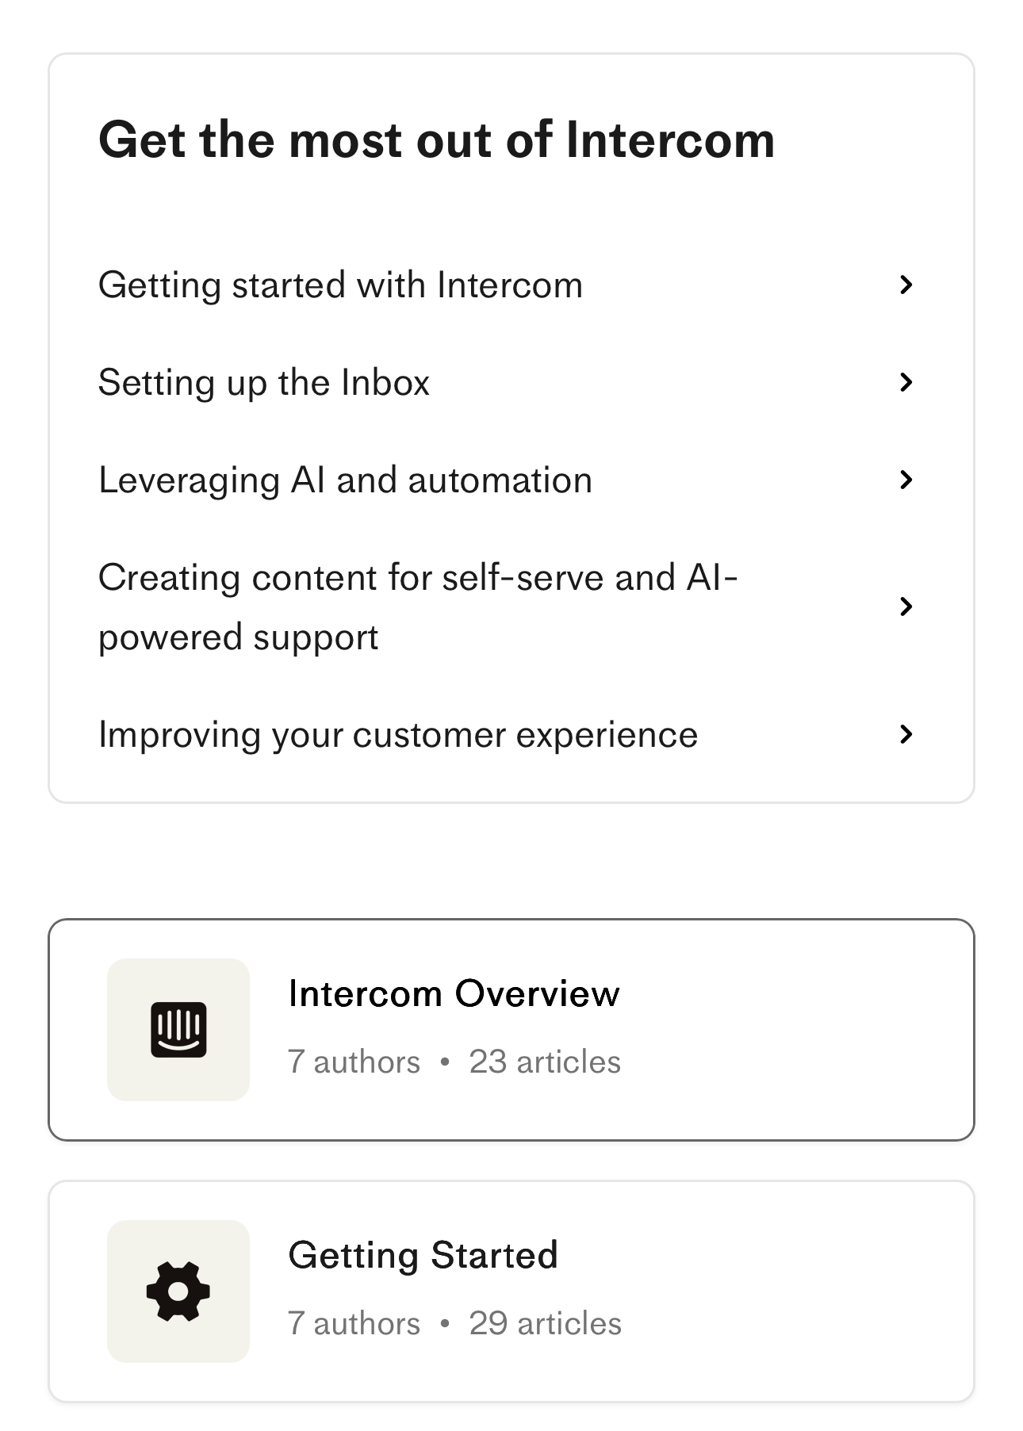
Don’t: “just nudge it a few pixels”
This is how clean layouts get messy. You nudge a card’s image 6 px left to “look centered,” the CTA gets 18 px side padding instead of 16/24, and suddenly edges don’t align and gutters are uneven. Users can’t always say what’s wrong—they just feel the jitter.
The more you nudge, the worse it gets, so you may end up with a completely misaligned layout like this one:
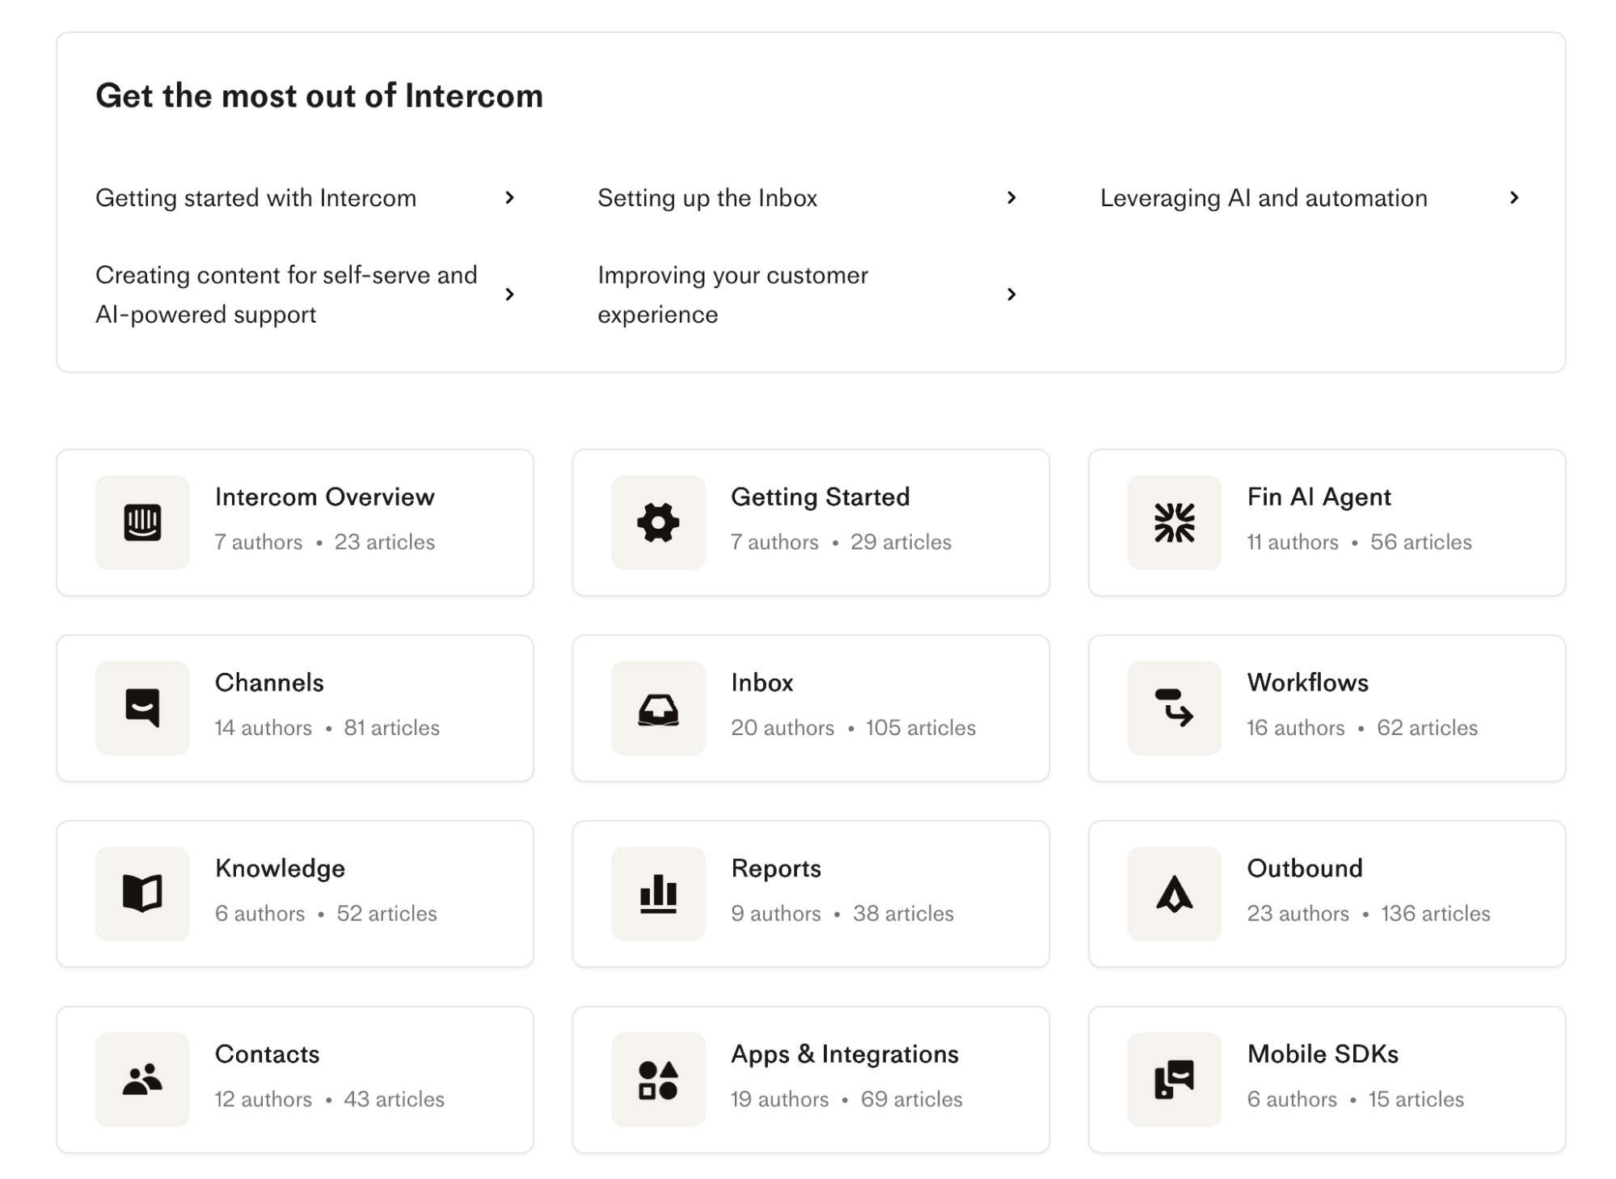
While this is an extreme example, it shows that eyeballing doesn't work. Make sure each card container snaps exactly to 4/12 columns. If something looks off, change the column span or adjust the grid tokens (gutters/margins)—don’t freehand pixels.

5. White space
White space (negative space) is the intentional empty space around and between elements. Some mistakenly consider it "wasted" space, but it's anything but.
White space lets content breathe, separates ideas, and gives the eye a path to follow.
To ensure adequate white space, pick a simple, modular scale (e.g., 4 / 8 / 12 / 16 / 24 / px) and use it everywhere. If you need some guidelines, here's what you can do:
- Cards: inner padding 16–24 px; outer gap between cards 24 px for desktop and 16 px on mobile
- Sections: top/bottom padding 48–64 px so sections feel distinct; keep side padding tied to your grid margins.
To stay consistent, you can lock these values into tokens (e.g., space-8, space-24) so designers and engineers snap to the same values instead of eyeballing.
Apple's website uses ample, consistent white space, which gives it a clean and polished look. Here's an example from the iPhone 15 product page:
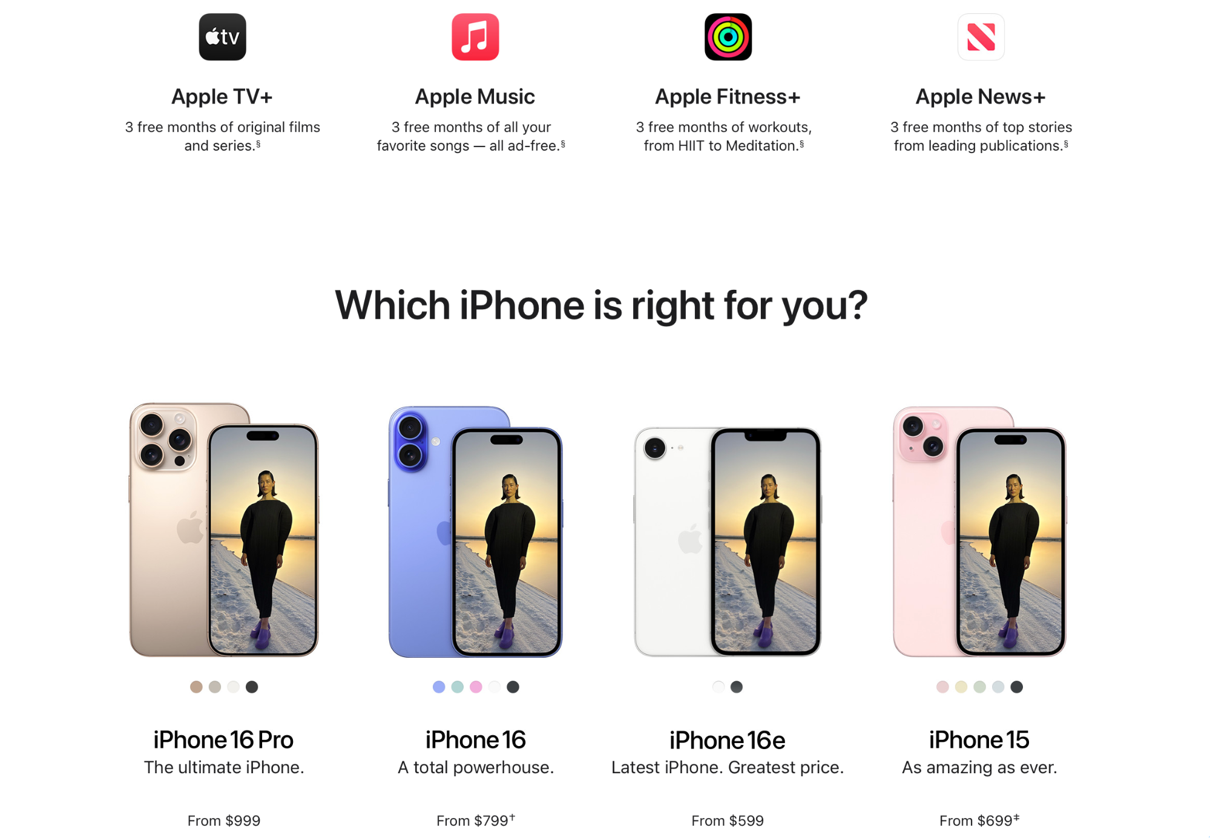
Now compare this to Arngren's homepage:
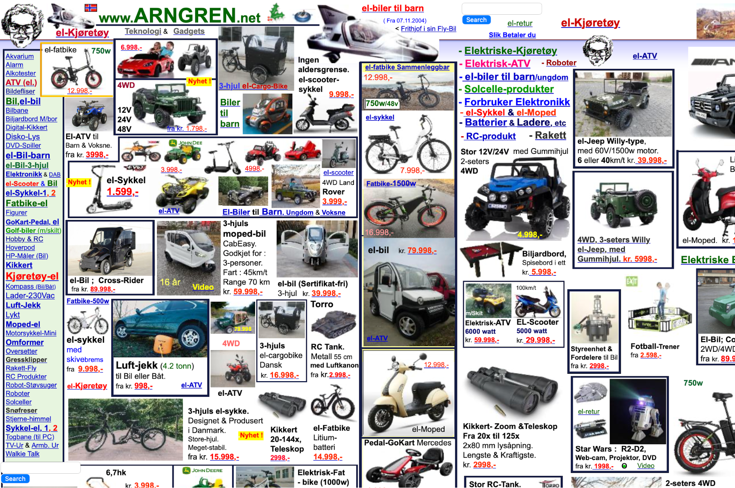
Product tiles, ads, and text are packed with inconsistent gaps and no column rhythm, which makes everything look chaotic and barely readable.
You can also use white space to group related items and separate them from others. For example:
- In a card, keep image ↔ title ↔ meta ↔ CTA on a consistent vertical rhythm (e.g., 8 / 16 / 24 px).
- Between different cards/sections, increase the gap (e.g., 32–48 px) so users know they’ve moved to a new idea.

6. Simplicity
Simplicity plays several important roles in web design. It lowers cognitive load so that users make decisions and take actions faster while reducing defects and rework across design, content, and engineering.
Following this principle comes down to one goal: make a page do one thing, and make sure it does it well.
In practical terms, this means keeping one primary action above the fold and making it the only filled button in the hero. Any secondary actions should be included as text links or outline buttons below the fold or in the footer.
You also need to steer away from non-essentials that create clutter, such as:
- Carousels
- Duplicate CTAs
- Auto-open modals
- Low-value badges
If you need any of these elements, make sure they're below the fold.
Simplicity isn't only a design feature but also a literary one. Replace jargon or technical slang with everyday words, and keep sentences at ~20 words to clarify the page's primary purpose in a way that doesn't cause mental strain.
Finally, limit color and type choices to a small, purposeful set. For example:
- 1 brand color (primary)
- 1 neutral (background)
- 1 accent (states/links)
The Dropbox Sign landing page follows pretty much all of these simplicity guidelines. It has a clear hero headline, one dominant CTA above the fold, short plain-English copy, and restrained color/typography.
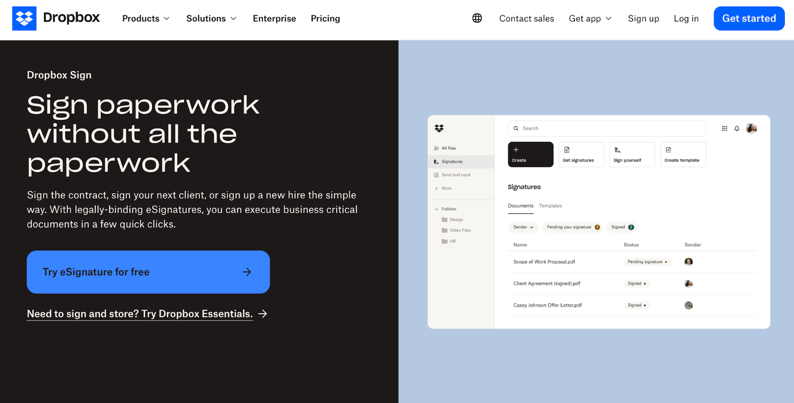

7. Accessibility and inclusivity
Accessibility ensures that your site doesn't exclude people with visual, motor, and other disabilities while improving the overall UX.
Clearer structure, better contrast, and predictable interactions help all users complete tasks faster.
The first thing you should focus on is the contrast of your site content. You need to meet the WCAG 2.2 AA guidelines, which recommend at least 4.5:1 for normal body text and 3:1 for large text (more on contrast a bit later).
You shouldn't rely on color alone to convey meaning. Pair it with icons, patterns, or labels (e.g., error text + icon, not just red) to ensure maximum visibility.
Tip: If you need help working out the right contrast, you can use tools like the WebAIM contrast checker.
Alt text is another key aspect of accessibility, as it helps visually impaired users and those using assistive technology understand the purpose and context of the page's visual elements.
Give every image accurate, concise alt text that states the purpose and explains it—for example:
- "Add to cart button"
- "Team photo at launch event"
- "Blue shirt on a gray background"
To support users with motor limitations, make sure your page is fully keyboard-operable. When you put the mouse away, you should be able to tab through in a sensible order, open/close menus and dialogs, and never get stuck in a keyboard trap.
An often overlooked detail you should focus on is labeling all form fields with error text and helper text when needed (e.g., “Use at least 8 characters with a number”).
GitHub's signup page is a perfect example of these guidelines. You can tab through all the key elements, and you'll see error messages in the relevant fields.
You’ll also see clear labels, high-contrast text, and a single primary action per step.
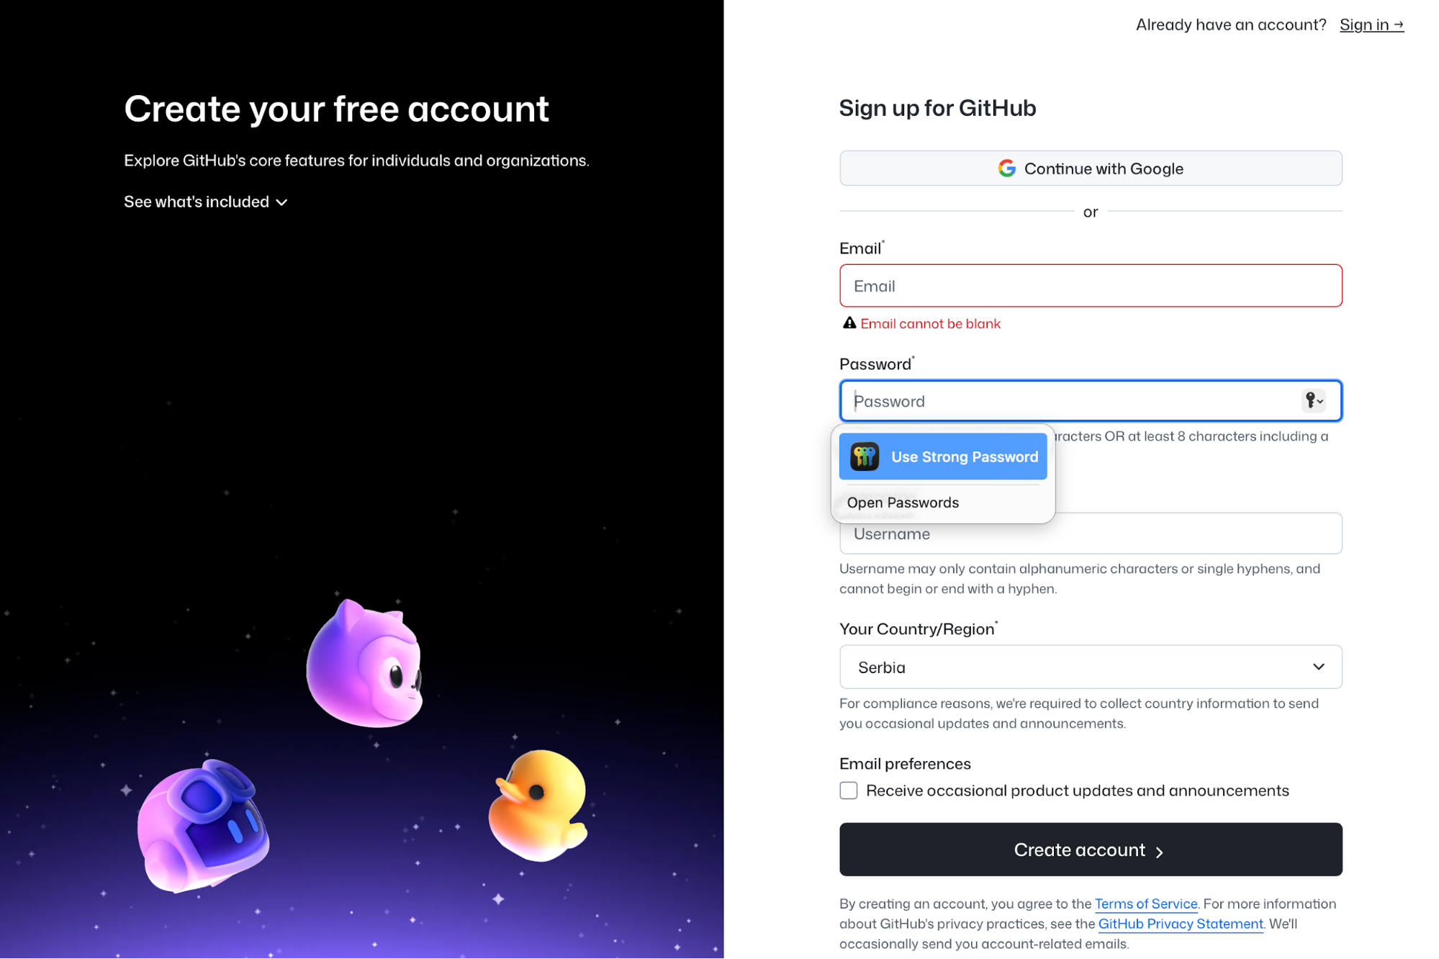
If you add any media besides images, provide captions for videos and transcripts for audio to ensure the inclusion of users with hearing disabilities. You should also avoid autoplaying audio and respect prefers-reduced-motion by offering a way to pause/stop animations.
Lastly, if color indicates status in charts, add textures, shapes, or labels so it’s understandable in grayscale or for color-blind users.

8. Mobile-first design
When designing a page, go mobile‑first and prioritize thumb‑reachable targets. They should be big enough to hit comfortably—at least ~44×44 pt on iOS (roughly a 44×44 px guideline)—so buttons and links are easy to tap.
You should also place primary actions where thumbs naturally rest (bottom half/center lines) and keep enough breathing room between taps.
It’s a tiny choice that prevents tapping errors and speeds task completion. Apple’s Human Interface Guidelines (HIG) reinforce generous hit areas and clear affordances, so you can use them as a reference point.
As the page switches from desktop to mobile, replace sprawling menus with a clear menu button (or concise tabs) and put search front and center because many users arrive intent-first.
Google’s guidelines also suggest mobile-first content and structure because the mobile version is used for indexing and ranking, so following them can help attract more website traffic.
To see if your page's structure works, try at least three devices and two browsers to catch layout jitters, keyboard overlays, and slow taps. For example:
Device | OS | Browsers to test
iPhone 14/15 | iOS | Safari, Chrome
Pixel 7/8 | Android | Chrome, Firefox
Samsung Galaxy S22/S23 | Android | Chrome, Samsung Internet
To see mobile-friendly design in action, open Airbnb's website on a mobile device. You'll notice that the search bar is the hero, the rest of the UI stays out of the way, and navigation is collapsed into concise controls.
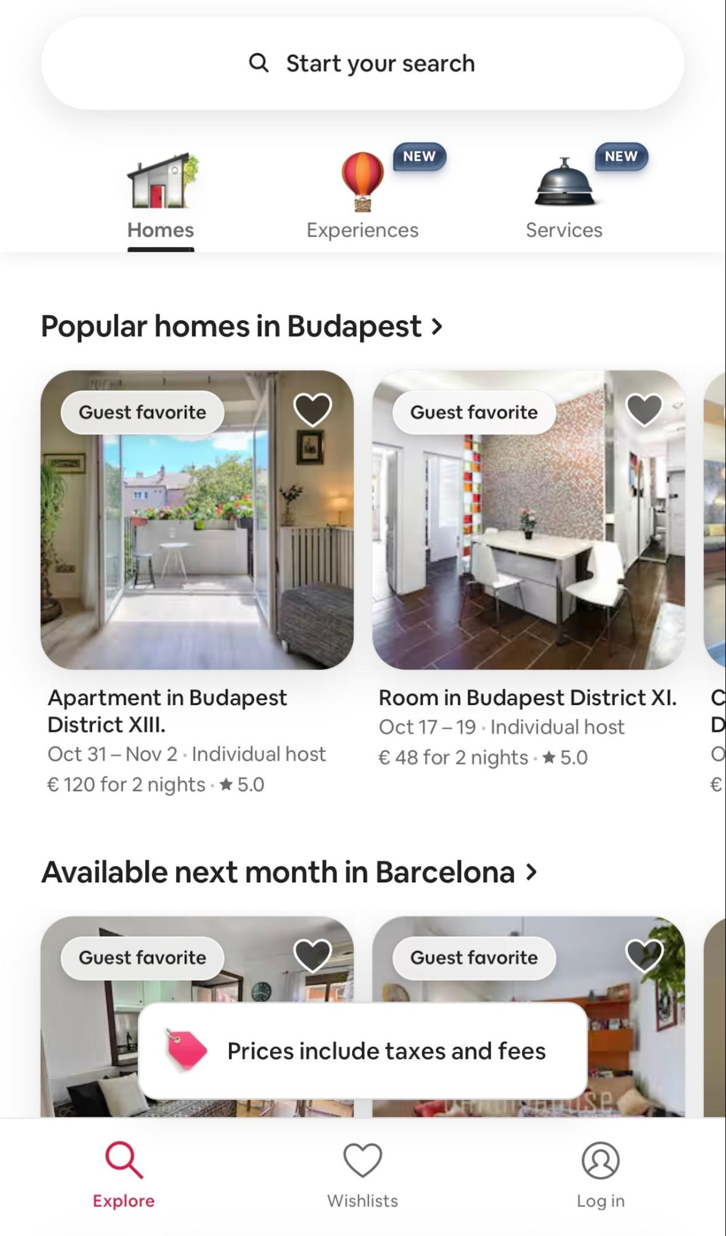

9. Balance
A balanced layout feels stable, and this stability turns into clearer reading paths and faster decisions. This makes it especially important for product pages, where you want to make purchasing decisions as smooth as possible.
You can use symmetrical or asymmetrical balance depending on your goal.
For example, Warby Parker uses symmetry through a classic two-column PDP: image gallery on the left, details on the right. The columns feel roughly equal, so your eye ping-pongs comfortably left and right to compare angles, colors, and specs.
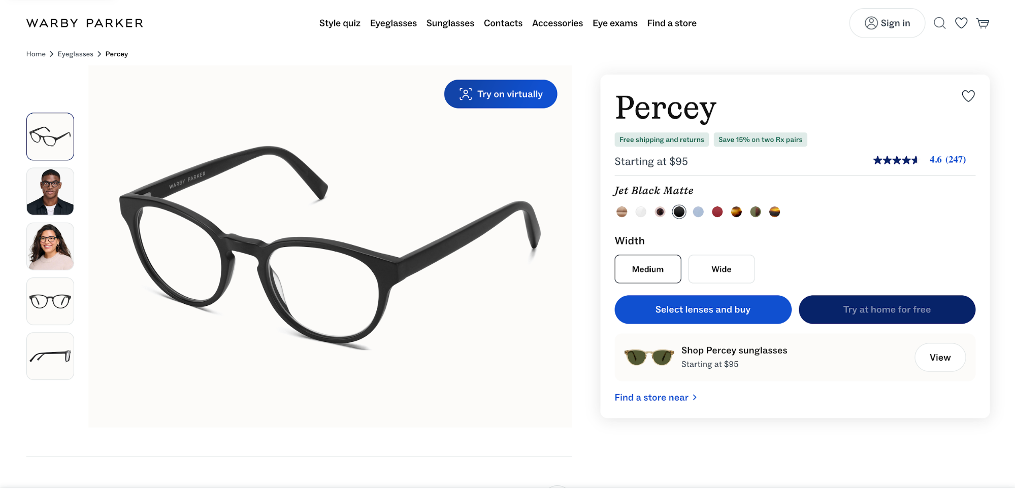
Symmetrical balance works best when your goal is clarity or when you want to provide comparisons. By contrast, asymmetry may work better when the goal is emotion, craftsmanship, and faster conversion for visually led products.
A good example is Allbirds, which gives more visual weight to the product media (large gallery) with a narrower right rail for size selection and Add to cart.
It’s still balanced, just not mirrored—the imagery sells texture and comfort first, while the compact select a size box keeps the action obvious above the fold.
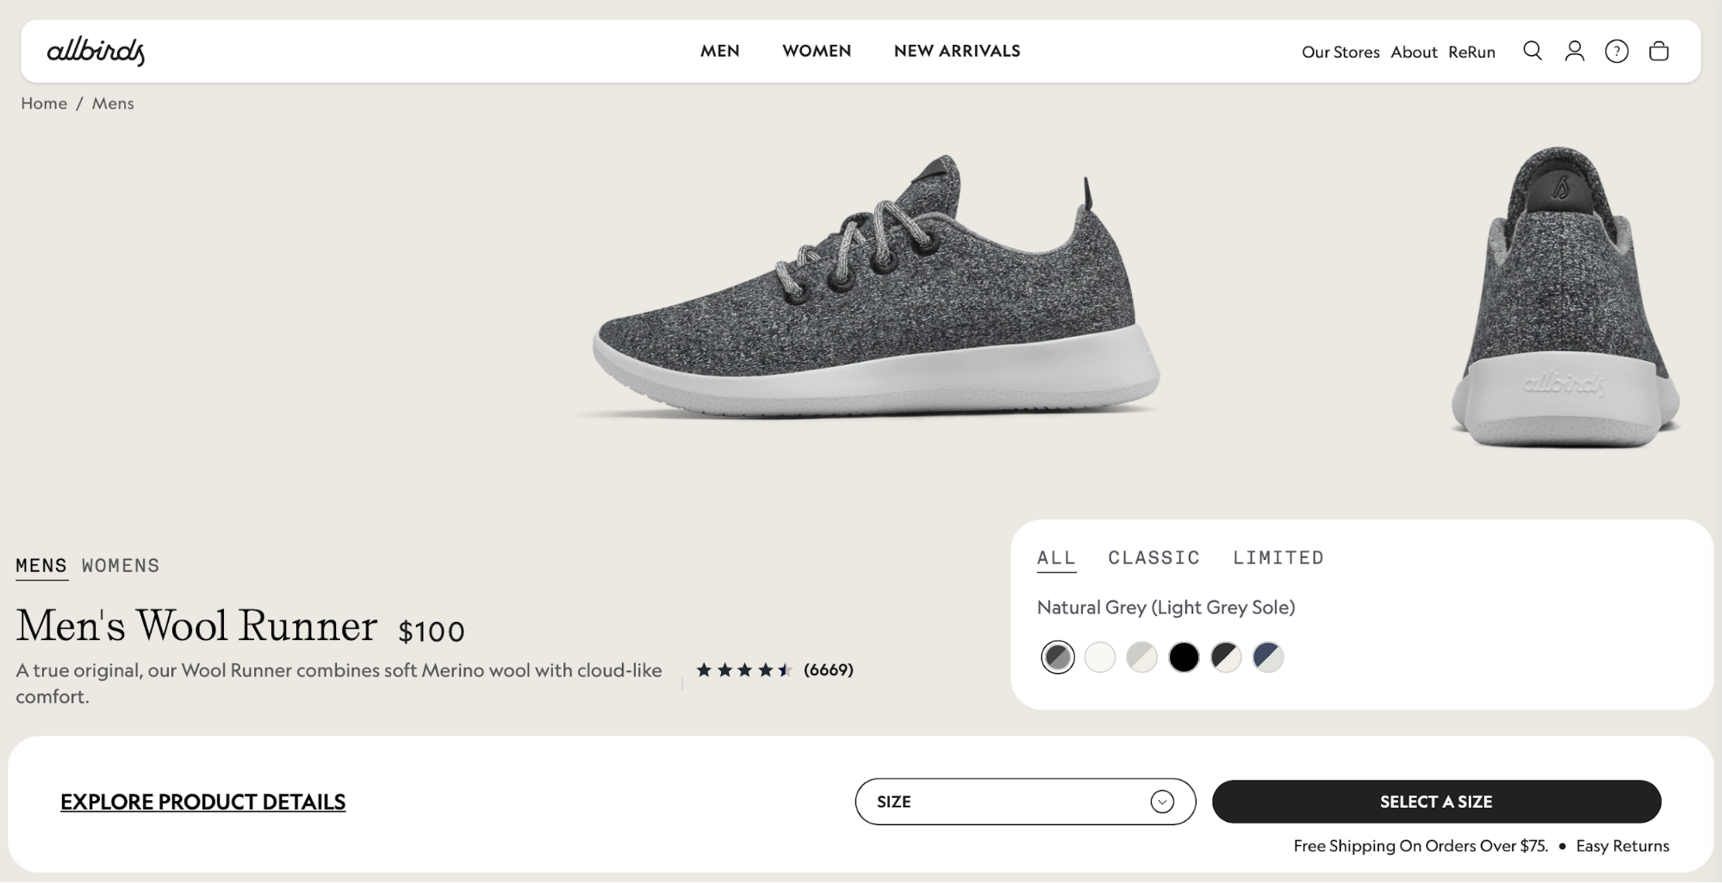
Whichever approach you take, make sure to strike the right visual balance. For example, if your left-side image is large, offset it with a clear right rail hierarchy (title, price, reviews, primary CTA) and a consistent type scale so text blocks don’t collapse into a heavy blob.
Also, keep the page’s optical center (the spot where the layout feels most stable) close to the true center.
If the top tilts left (large photo), reinforce the right with a slightly larger price/CTA block or a sticky buy box so the page doesn’t feel lopsided as you scroll.
Pay special attention to the spacing rhythm. Uneven gaps make pages feel like they’re sliding downhill, so decide on a spacing scale (e.g., 8/16/24/32 px) and apply it down the page:
- Inside the details column, keep title → price → ratings → options → CTA on consistent steps (e.g., 8/8/16/24).
- Between sections (e.g., from “Highlights” to “Specs”), jump up a step (e.g., 32–48 px) so groups read as distinct.
- Align card edges and captions to the grid. If something looks off, change the span or the token instead of nudging pixels.

10. Purpose‑driven design
Each page must serve a specific purpose that the user will understand clearly the moment they reach a page. This means you should avoid vague actions like "click here" or "take the next step."
You need to clarify exactly what will happen when the user clicks on a button, so make sure all CTAs are descriptive—for example:
- "Book a call"
- "Download the whitepaper"
- "Get a free trial"
When you decide on the purpose, trim everything that doesn't serve it. This includes:
- Other CTAs
- Carousel slides
- Pop-ups
- Off-path links
Make sure the purpose is reflected by one filled primary button above the fold, and turn everything else into text links or move it below the fold.
You can tie specific KPIs to the page's purpose to measure the success rate. For example:
- “book a demo”: track primary CTA clicks → form start → form submit → calendar booked
- “start a free trial”: track primary CTA clicks → account created → first key action (e.g., import, invite)
- “download the guide”: track CTA clicks → email capture → file delivered
HubSpot's landing page is a great example of a page with a clear purpose
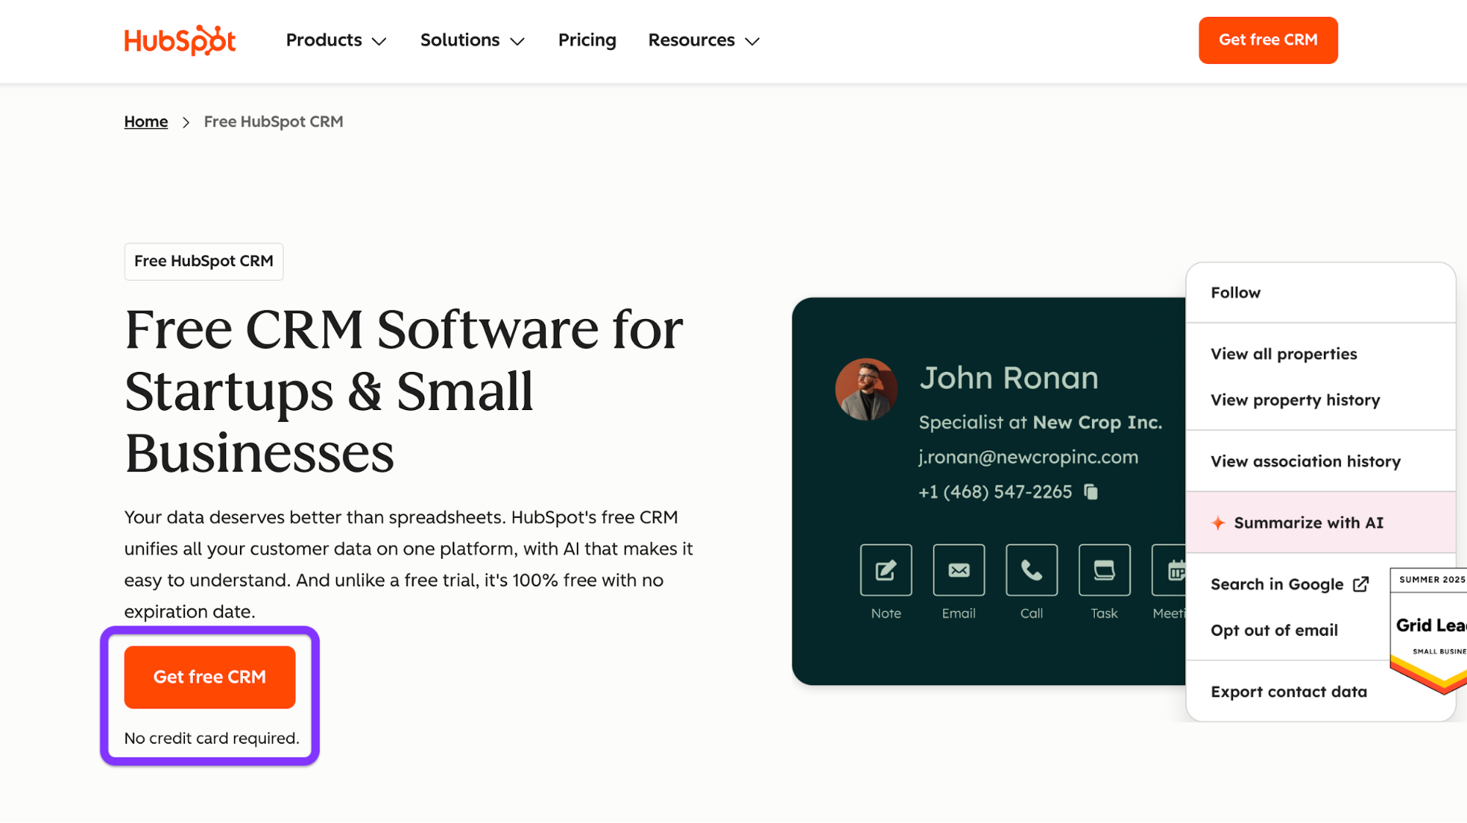
The CTA is clear and descriptive, and there's a reassurance line underneath it ("No credit card required.") that further encourages the action and reduces friction.

11. Consistent branding
Consistency turns one-off screens into a brand experience. The user sees recognizable colors, type, buttons, and voice that reflect your unique brand identity and make your site more memorable.
To ensure consistency, lock in brand tokens and reuse the same parts everywhere. Here's an example:
- Colors: brand/primary, brand/secondary, neutral/100–900, semantic/success|warning|error.
- Type scale: H1 36–40, H2 24–28, H3 20–22, body 16, caption 12–14.
- Radii and shadows: radius/sm 4, md 8, lg 12; one shadow for cards, one for overlays.
You should then wire components to those tokens and reuse them site-wide, from headers and footers to form fields and badges.
When checking for consistency, don't just glance over your pages. Instead, follow a systemized checklist. For example, here's what the checklist would look like for header and footer consistency across three templates:
- Templates: Home, Article, Checkout.
- Header:
  - Identical logo size and placement
  - Same nav item order and labels
  - One primary CTA style (filled) and the same hover/focus states
  - Minimal header on checkout (but still the same height, brand color, and iconography)
- Footer:
  - Same background tone, link groups, social icons, and legal text
  - Consistent spacing and link styles
  - Newsletter field uses the same form component as elsewhere.
- Tokens/components audit:
  - Colors match tokens (no off-brand hex codes)
  - Text sticks to the type scale
  - Buttons/cards use the same radii and shadows
  - Focus rings look identical
- Behavior: active states, scroll behavior (sticky/not), and breakpoint swaps (e.g., menu collapse) behave the same on all three pages.
Besides design choices, consistency heavily relies on your brand voice. You must choose the tone of voice that resonates with your audience and ensure continuity in all your content and copy.
If you need examples, here are a few ways you can approach error messages:
- Helpful: “We couldn’t save your changes. Try again, or save a copy.”
- Specific + actionable: “Password needs 8+ characters, including a number.”
- Human + calm: “Card was declined. Check the number or try another card.”

12. Content structure
The right content structure ensures seamless and intuitive navigation. It also helps search engines crawl your content more effectively, increasing the pages' chances of ranking well in search results.
Before publishing content, map out the topics and subtopics. Then, make sure that navigation, breadcrumbs, and URLs mirror that structure.
For example, the structure can look like this:
- Projects
  - Overview
  - Templates
  - Permissions
- Tasks
  - Creating tasks
  - Assignments & due dates
  - Recurring tasks
In this case, you'd need to check the following boxes:
- Navigation: Top nav uses the top-level topics (Projects, Tasks,).
- Breadcrumbs: Home › Tasks › Assignments & due dates
- URLs: Keep slugs readable and consistent—/tasks/assignments-due-dates
As for the content on each page, use meaningful headings that convey specific information—for example:
- H1: States the outcome: “Plan and track projects.”
- H2/H3: Break the job into steps or questions: “Create a project,” “Invite teammates,” “Track progress on a timeline.”
You'll also likely use images, but focus on those that add value instead of purely decorative visuals. And if the image tells something, include it in the caption that reflects the key point.
For example, Mailchimp uses visuals to present its service, and it captions them with engaging, benefit-driven copy.

13. Readability
Low readability is bound to cause a poor user experience, so you should be strategic with type sizes, line lengths, and other factors that ensure you don't end up with large, monotonous blocks of text.
General recommendations include:
- Body text at 16–18 px
- Line length ~45–75 characters
- Line height 1.4–1.6
This combination gives content room to breathe without being overbearing for readers. If a paragraph still feels heavy, widen line height one notch before shrinking the font—small type should always be a last resort.
You should also add headings to make the content more scannable and skimmable. Use sentence case instead of title case for subheadings (“Manage projects faster,” not “Manage Projects Faster”), as doing so makes headings less formal and easier to process.
When writing headings, put the important words first so that readers get the point at a glance. For example, “Pricing for teams” beats “Our approach to pricing” because the heading starts with the key word a reader cares about.
To make sure your content stays readable, run every page through this checklist:
- Short paragraphs: 2–4 sentences each. Break up walls of text, and don’t fear white space.
- Plain words: Choose “use” over “utilize,” “help” over “facilitate,” “start” over “initiate.”
- Active voice: “Upload your file” is more impactful than “Your file can be uploaded.”
- Front-load meaning: Lead with the outcome (“Save time with templates”) before support detail.
- One idea per sentence: If you need too many commas and semicolons to hold it together, split it.
- Helpful subheads: Every 3–5 paragraphs, add a clear signpost for what's to come.
- Consistent terms: Pick one label (“Sign in” vs. “Log in”) and stick with it.
- Lists wherever applicable: Add numbered lists and bullet points to improve skimmability.
- Contrast and size: Make sure that body content meets 4.5:1 and is readable on a phone.

14. Responsive images and media
Images are powerful assets, but they're also among the heaviest ones. You should carefully add them to your page to prevent issues like slow loading and accessibility issues.
Specifically, prioritize modern formats like AVIF and WebP because they enable smaller file sizes without compromising quality.
You can serve JPEG/PNG as a fallback so older browsers still render your visuals if they don't support the newer formats.
Your images should also adapt to screen sizes, which you can ensure by using the <picture> element with srcset + sizes to offer multiple resolutions and formats.
Here's an example piece of code that brings it all together:
<picture>
<!-- Modern formats first -->
<source type="image/avif"
srcset="/hero@800.avif 800w, /hero@1200.avif 1200w, /hero@1600.avif 1600w" />
<source type="image/webp"
srcset="/hero@800.webp 800w, /hero@1200.webp 1200w, /hero@1600.webp 1600w" />
<!-- Fallback JPEG; note the width/height for layout stability -->
<img src="/hero@1200.jpg"
srcset="/hero@800.jpg 800w, /hero@1200.jpg 1200w, /hero@1600.jpg 1600w"
sizes="(max-width: 768px) 90vw, (max-width: 1200px) 80vw, 1200px"
alt="Project dashboard showing tasks completed and a green success badge"
width="1200" height="720" decoding="async" />
</picture>

Here's what's happening in the above code:
- srcset lists available widths.
- sizes tells the browser how wide the image will display at different breakpoints, so it picks the smallest file that still looks sharp.
- width/height (or CSS aspect-ratio) prevents layout shift while the image loads.
Another step you should take is to compress heavy visuals and lazy-load below-the-fold images. Doing so prevents unnecessary work during the first paint and makes your page faster. Lazy-load anything you don’t need immediately, and focus on the elements the user will see first.
For each image you add, include alt text that explains what the image does or what information it conveys.
Don't use file names as alt text (e.g., alt="IMG_2049.avif") because this is meaningless to users of screen readers. The same goes for vague alt text that doesn't convey the contents (e.g., alt="Chart")
Unless an image is purely decorative (in which case you can use alt="" so it's skipped), add meaningful alt text as explained in the accessibility section above.

15. Color strategy
Colors don't just serve an esthetic purpose. You need to define them by their roles and impact on the user experience, not the hues.
This "color by role" model looks something like this:
- Primary: interactive emphasis (filled CTAs, active tabs, selection)
- Secondary: supportive UI (secondary buttons, info links)
- Semantic: success / warning / error / info (form validation, banners)
- Background / Surfaces: page canvas, cards, input fields
- Text: default, subdued, inverse
Less is more when it comes to the color palette, so define and document all the constraints you'll use to ensure consistency. For example:
- One primary color site-wide; one accent per screen (max).
- Neutrals for most surfaces; reserve vibrant hues for actions and semantics.
- Do not use semantic colors (green/red) for decorative accents—keep them for feedback only.
- Components inherit tokens; no local hex overrides in templates.
After defining colors, make sure there's sufficient contrast by validating every combination against WCAG 2.2 AA (e.g., body text ≥ 4.5:1). During reviews, run a quick pass in a color-blind simulator (protanopia/deuteranopia/achromatopsia) and ensure the page retains its purpose via icons, labels, or patterns, not color alone.
Notion uses a simple but effective color palette.
There's a minimal neutral canvas (light background, high-contrast black text) with a single, consistent accent reserved for primary CTAs and key highlights. Because neutrals do the heavy lifting, CTAs stand out without fighting other colors, and text remains highly legible across sections.
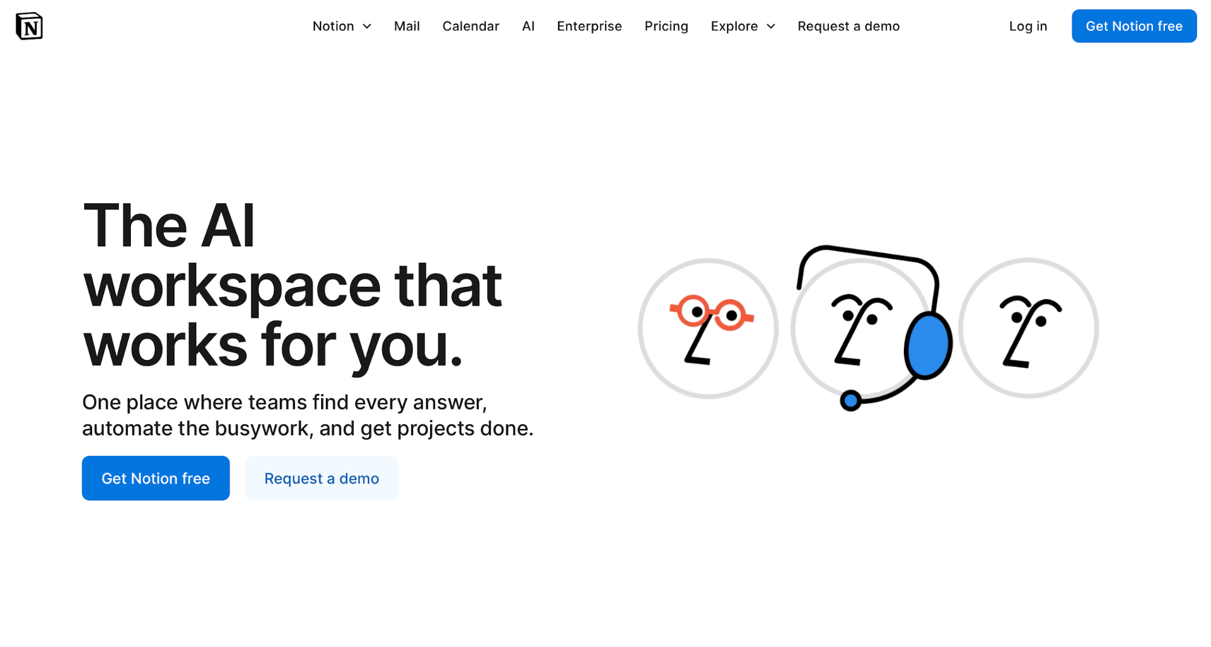

16. Contrast and legibility
High contrast reduces reading effort and mistake clicks, especially on mobile and in bright light. To ensure it, follow the WCAG 2.2 AA guidelines, most notably:
- Normal body text: ≥ 4.5:1
- Large text (≥ 18 pt or 14 pt bold): ≥ 3:1
- UI components (buttons, inputs, icons, focus outlines): ≥ 3:1 against adjacent colors
These references aren't just numbers—they translate to tangible effects on the reading experience. For example:
- Pass (AA): Dark text on white with a ratio of 7.0:1 (e.g., typical “near-black” body copy)—comfortably above 4.5:1, so paragraphs remain legible at 16–18 px.
- Borderline: Mid-gray body text at 4.6:1—technically passes AA for normal text, but leaves little room for small sizes or thin weights.
- Fail: Light gray body text at 3.4:1—below the 4.5:1 requirement; expect eye strain and missed words.
You must also ensure that focus indicators and hover states meet contrast guidelines. Focus rings should stand out at ≥ 3:1 against both the component and the background (e.g., a bold outline that clearly contrasts with a button’s fill).
Hover/active states shouldn’t only change color. They must also adjust weight (border width), style (underline for links), or shadow so the state remains obvious for color-blind users.
If you plan on using dark mode, re-check ratios to maintain legibility because light text on dark backgrounds must still hit ≥ 4.5:1. While off-white text on near-black at 13:1 is good, medium gray on charcoal at 3.1:1 won't work.
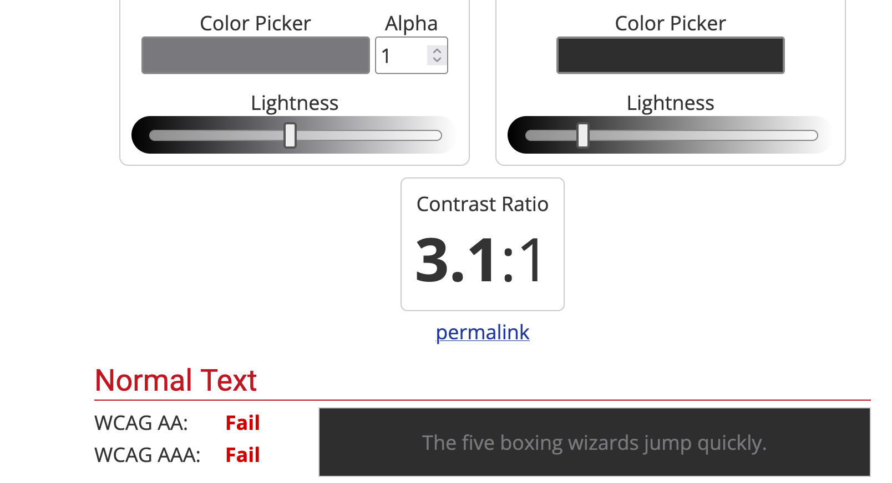

17. Load time and performance
Few issues can be as frustrating to users as slow-loading sites. Google's research shows that users are 32% more likely to leave a page if its load time increases from 1 to 3 seconds.
To minimize load time, focus on three metrics known as Core Web Vitals:
Metric | What it is | Target
LCP (Largest Contentful Paint) | Time from page load to when the largest visible content element (e.g., hero image or big text block) finishes rendering | LCP ≤ 2.5s
CLS (Cumulative Layout Shift) | The total of all unexpected layout shifts while the page is open | CLS ≤ 0.1
INP (Interaction to Next Paint) | The delay between a user interaction and the next visual update | INP ≤ 200ms
You can use a tool like PageSpeed Insights to check these metrics and identify issues. For example, we can see that this article by Healthline passes the Core Web Vitals test on mobile devices:
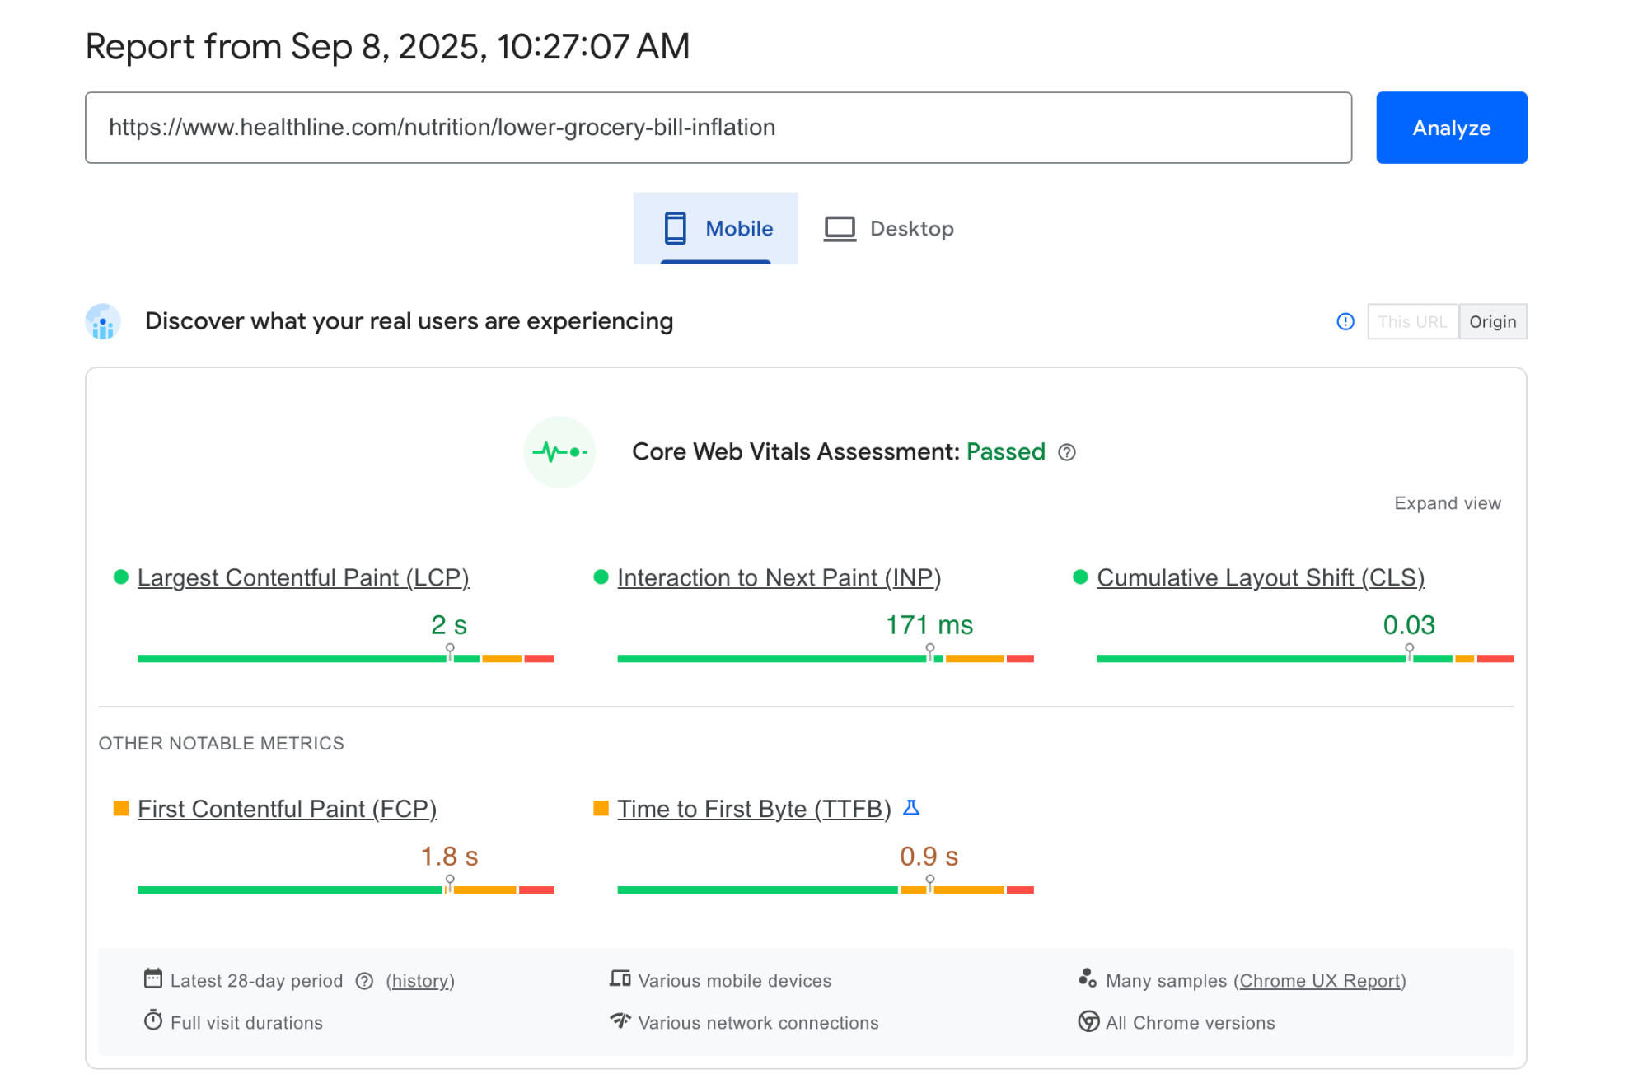
If your page doesn't, the top three fixes you should try are:
- Trim and delay JavaScript: Cut unused libs, ship ESM, split bundles, and defer anything non-critical.
- Serve media and fonts smartly: Compress/resize images, preload the hero image, subset fonts, and use font-display: swap.
- Stabilize layout: Always set dimensions/aspect-ratio for images, ads, and embeds to kill layout shift.
Deferring non-critical scripts is often the most effective fix, which involves loading only what's needed for the first paint and queueing everything else. Here's an example piece of code that makes this happen:
<!-- Critical script (small, needed for above-the-fold interactivity) -->
<script type="module" src="/app-critical.js"></script>

<!-- Non-critical scripts: defer or load after first interaction -->
<script src="/analytics.js" defer></script>
<script>
// Load heavier stuff on idle
if ('requestIdleCallback' in window) {
requestIdleCallback(() => import('/charts.js'));
} else {
setTimeout(() => import('/charts.js'), 1500);
}
</script>
In many cases, you need to tell the browser what’s most important for the first screen, like so:
<!-- Hero image used in the above-the-fold section -->
<link rel="preload" as="image" href="/img/hero-1200.avif" imagesrcset="/img/hero-800.avif 800w, /img/hero-1200.avif 1200w"
imagesizes="(max-width: 900px) 90vw, 1200px" fetchpriority="high">

<!-- Critical CSS (above-the-fold only) -->
<link rel="preload" as="style" href="/css/critical.css">
<link rel="stylesheet" href="/css/critical.css">
Poorly optimized fonts can kill your LCP without you knowing it, so ship performance-friendly ones. To make this happen, subset to your language (e.g., Latin only), drop unused weights, and use a system-font stack for body if possible. Here's an example:
<!-- Preload only the weights/styles you actually use -->
<link rel="preload" href="/fonts/Inter-latin-400.woff2" as="font" type="font/woff2" crossorigin>
<link rel="preload" href="/fonts/Inter-latin-600.woff2" as="font" type="font/woff2" crossorigin>

<style>
@font-face {
font-family: 'Inter';
src: url('/fonts/Inter-latin-400.woff2') format('woff2');
font-weight: 400;
font-display: swap; /* show system font first, swap when ready */
}
@font-face {
font-family: 'Inter';
src: url('/fonts/Inter-latin-600.woff2') format('woff2');
font-weight: 600;
font-display: swap;
}
</style>
As for CLS, you can cut it at its roots by setting width/height or aspect-ratio on every image/video in HTML, like so:
<img src="/card.webp" width="600" height="400" alt="Product card">
<!-- or -->
<img src="/card.webp" style="aspect-ratio: 3 / 2;" width="600" alt="Product card">
Finally, add and enforce a performance budget for each item to set clear boundaries. Here are some reference points to follow
Budget item | Limit (mobile)
Total JS (initial) | ≤ 170 KB compressed (≈ 500 KB uncompressed)
Largest image (above fold) | ≤ 180 KB
Fonts (combined) | ≤ 100 KB
Total requests (initial) | ≤ 35
Hero HTML | ≤ 35 KB

18. Use common scanning patterns (F/Z)
Users don't read every word on a page—they scan the highlights until they find something worth focusing on. To accommodate this, web designers often use the F and Z scanning patterns.
The F pattern is better for text-heavy pages like blog posts. Here's a quick "sketch" of the pattern:
Top row: logo → primary nav → utility.
Left column start: H1, standfirst, key links.
Second row: subhead or featured links under the H1.
Left spine: section links continue down the page.
A good example of an F pattern is this Forbes article. You'll see a left-anchored headline + standfirst, and body text set in a single readable column with clear sectional signposts.

By contrast, the Z pattern is better for simpler and more marketing-focused pages like landing pages. Here's what it generally looks like:
- Top-left: logo
- Top-right: primary CTA
- Diagonal sweep through headline + subcopy
- Bottom-right: CTA (or key proof) to close the “Z”.
Zapier's signup page is a classic example of the Z pattern. Your eye goes top-left (logo) → top-right (primary CTA ) → diagonally through the hero headline + visual → and finishes along the bottom row at the form/CTA.

Whichever pattern you choose, place the key cues along the scan path. Line up the logo, nav, headline, and the primary CTA along the expected path (top row and the diagonal in Z; top rows and left spine in F). Then do a sanity check with a quick heatmap/click-map run to confirm people actually follow the trail.
In some cases, you may want to break the pattern to highlight the key action more prominently. For example, Stripe’s mobile hosted Checkout centers the entire experience on a single, focused payment form with minimal chrome.
There's no top nav to scan left→right and no diagonal sweep, so the user’s attention is pulled straight to the middle column.
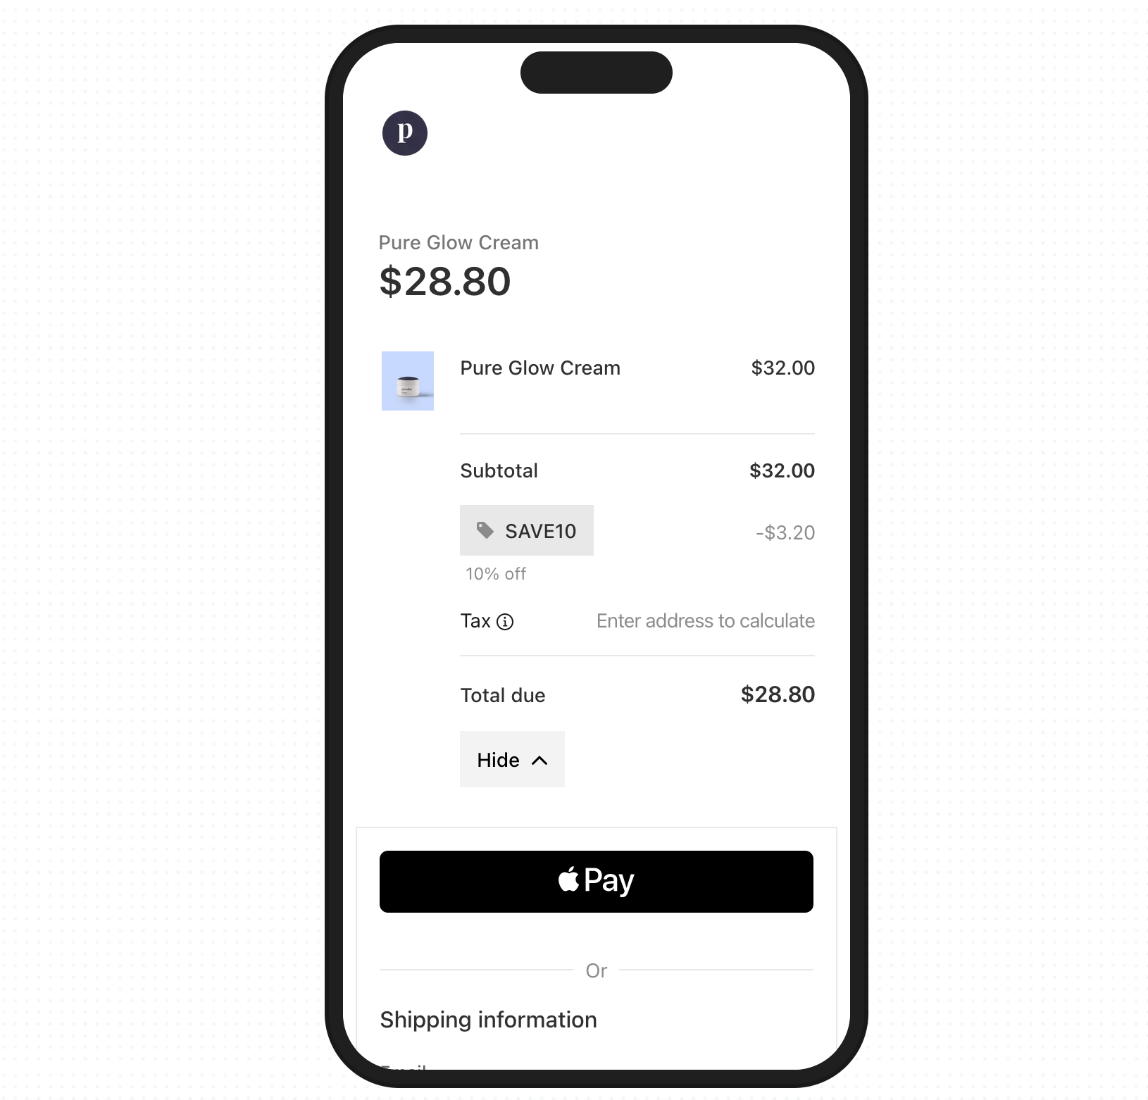

19. Testing and iteration
Web design is an iterative process, so you should run small, fast tests to quickly spot and resolve issues. Take 5–7 users who match your target audience and run task-based sessions of 15–20 minutes each. Give users concrete goals, such as:
- "Find pricing for the Team plan"
- "Book a demo"
- "Add the blue sweater (M) to cart"
As the test progresses, record metrics like:
- Task completion (yes/no)
- Time to complete
- Notable errors (missed clicks, backtracks, wrong paths)
Once the tests are completed, triage findings with analytics to fix the biggest pain first. Ask yourself whether users are reaching the CTA or key content, and if not, where do they drop from a specified path (e.g., CTA click → form start → submit).
Gather the results, and then ship changes with documented modifications and improvements. You can keep a lightweight changelog where each entry links to a metric you expect to move. For example:
- April 19: Moved “Start free trial” into hero, demoted “Contact sales” to link.
  - Expectation: Primary-CTA CTR +20%, time-to-task −15%.
- April 26: Increased body contrast to 7:1; added focus rings.
  - Expectation: Form completion +10%, error rate −20%.
- May 02: Collapsed menu on mobile; surfaced search.
  - Expectation: Search starts +25%, bounce −10%.

Key takeaways
- Web design principles are reusable rules that shape layout, interaction, content, and accessibility so pages work consistently.
- Shared principles reduce rework, speed decisions across teams, and tie choices to measurable outcomes like time-to-task or form completion.
- Leverage clarity by removing noise and keeping one primary action per view so that your pages guide users to the most impactful actions.
- Use size, contrast, and placement (H1 → H2 → body → CTA) to guide the eye and make the next step obvious.
- Limit top-level items to 5–7, separate utilities, and design for “find top tasks in two clicks” with breadcrumbs for depth.
- Use a 12-column grid with defined gutters/margins to keep alignment clean and responsive across breakpoints.
- Apply a simple spacing scale (e.g., 8/16/24/32) to group related content and improve scanning without extra chrome.
- Make each page do one job and place a single filled CTA above the fold; demote or delete everything else.
- Meet WCAG 2.2 AA guidelines, provide alt text and visible focus, and ensure full keyboard operability to help everyone navigate pages regardless of disabilities.
- Prioritize mobile-friendly design with thumb-friendly targets (~44×44), collapsed nav, and prominent search for intent-driven visits.
- Use symmetrical balance for clarity/comparison or asymmetrical for impact, and keep the optical center steady as users scroll.
- Ensure consistent branding by locking in tokens (color, type, radii) and reusing components so headers, cards, and buttons feel the same site-wide.
- To ensure readability, set body at 16–18 px, ~45–75 characters per line, 1.4–1.6 line height, and write sentence-case headings with front-loaded keywords.
- Serve AVIF/WebP with srcset/sizes, compress, lazy-load below the fold, and write purpose-driven alt text so that visuals stay responsive.
- Define role-based colors (primary/secondary/semantic), limit accents to one per screen, and validate contrast and color-blind safety.
- Set a ≥4.5:1 contrast for body text and ≥3:1 for UI states, and ensure clear focus/hover in both light and dark modes.
- Target LCP ≤ 2.5 s, CLS ≤ 0.1, INP ≤ 200 ms by deferring non-critical JS, preloading true criticals, and optimizing fonts.
- Use F scanning patterns for text-heavy pages and Z patterns for simple marketing, placing logo, nav, headlines, and CTAs along the scan path.
- Run usability quick sessions with 5–7 users, pair insights with funnels/scroll depth, document changes, and re-test to confirm lifts.

Principle 1: Alignment
The alignment graphic design principle is the arrangement of text and elements to create order and visual connection. You accomplish this by aligning elements to a common edge, center, or baseline.

This enhances readability and guides viewers’ eyes through content in a digestible way. For example, text is often aligned left since most languages read from left to right.

How to apply: Use a layout grid to organize text and graphic design elements to create a visually structured design. In Figma, you can add layout grids to any frame or component for more precise and consistent alignment. You can also use Figma’s auto layout settings to align text layers or icons with text to ensure visual balance.

Principle 2: Contrast
Contrast creates a noticeable difference between elements to add visual interest and emphasize important information within designs. This graphic design principle is crucial since the human eye naturally gravitates toward elements with higher contrast.

While contrasting colors are a common way to emphasize contrast, you can also apply it by using different sizes, textures, shapes, weights, and alignment of elements in designs—for example, the color red against a white background or a large, bold font for a call to action.

How to apply: Focus on the most important details in your design and use a higher contrast to make them stand out. Avoid applying too much contrast, though, as this can lead to a visually jarring and confusing design.

Principle 3: Balance

Balance focuses on distributing the visual weight of design elements to create a cohesive design. It helps establish unity between elements to effectively communicate your message. You can typically achieve this through symmetrical or asymmetrical balance.

Symmetrical balance focuses on the even distribution of visual weight to create harmony within a design. Elements on each side of the design have an even weight.
Asymmetrical balance uses asymmetry to create a dynamic and visually exciting design composition. Elements on one side of the design are balanced by elements of a different weight on the other side.
How to apply: Use grid lines as a guide to help position elements symmetrically or asymmetrically, and strategically use white space to prevent your design from looking cluttered.

Principle 4: Hierarchy
You can achieve visual hierarchy by strategically arranging and emphasizing elements in order of importance. This helps viewers understand your content and quickly directs them to the most important information.

For example, a social media ad for a new restaurant may feature a photo of a popular dish as its focal point with a bold, attention-grabbing headline prominently placed at the top to announce its grand opening. This clearly establishes the main goal of attracting customers to the grand opening event. Less critical information like the address and contact information might be placed at the bottom of the graphic in a smaller font size.

How to apply: Convey your message by placing the most important information at the top, then use colors, bold fonts, and other design elements to emphasize crucial details.

Principle 5: Color
Color can evoke emotions, communicate messages, and shape the perception of your brand. In graphic design, colors aren’t chosen at random. You can use color theory and color psychology to choose a color palette that will leave a lasting impression. While these two concepts may seem similar, there’s an important distinction:

Color theory refers to how colors work together to create harmony based on their placement on the color wheel. For instance, shades of blue and orange are complementary colors because they are opposite each other on the color wheel.
Color psychology is the study of how colors influence human behavior and emotions. For example, the color yellow can elevate your mood, while the color blue can evoke a sense of calmness.
It’s also important to consider accessibility when creating a color palette to ensure colors are easily distinguishable, especially for those with color vision deficiencies.

How to apply: Use your knowledge of color theory and color psychology to create a color palette that evokes the right emotions and aligns with your brand identity. Figma’s color palette generator can help you create a custom color scheme. Select your desired color palette, then bring it right into your Figma Design.

Principle 6: White space
Imagine a design where text and icons had little to no space in between. It would feel overwhelming and be hard to visually digest. White space, or negative space, is the empty area between and around text and design elements.

When done right, white space gives your design breathing room, helping create balance, improve readability, and prevent designs from feeling cluttered. By creating visual separation between design elements, you can emphasize important details and guide a user’s eye more effectively.

How to apply: Consider the purpose of your design to determine the appropriate amount of white space. For example, a minimal design style might include more white space, while an information-packed design might have less. Use Figma’s auto layout features to specify how far apart you’d like objects to be or set uniform padding to ensure consistency.

Principle 7: Proportion

Proportion in the principles of graphic design refers to the size and weight of design elements in relation to one another. Maintaining proportion creates a visually pleasing balance between objects and is a great way to establish visual hierarchy, as large objects are naturally seen as more important.

The North Face logo is a great example of using proportion to create a harmonious design. It uses a bold but readable font that complements the half-dome icon without overpowering it.

There may be instances where you’re creating a humorous design that requires more exaggerated proportions to emphasize your unique design style. Play around with proportions to see what feels right for your content type.

How to apply: Use your grid system as a baseline to ensure consistent proportions between elements. Consider each element’s visual weight and balance heavier-weighted objects with lighter ones to create harmonious proportions.

Principle 8: Repetition
Repetition is when identical or similar elements are reused throughout designs. You can achieve repetition by repeating colors, textures, shapes, patterns, or fonts. This creates a sense of cohesion and balance and establishes a visual rhythm to guide viewers’ eyes seamlessly through the design.

Repetition can also help establish your brand identity to create memorable and impactful designs. For example, a cohesive color palette and font types strengthen brand recognition.

How to apply: Create a design system to ensure consistency for repetitive elements across projects. Design systems in Figma make it easy to establish a consistent brand identity and achieve unity across designs.

Principle 9: Rhythm

Rhythm creates a sense of movement, flow, and visual interest within designs. It’s similar to repetition but focuses on the placement and spacing between the repeated elements.

There are four types of rhythm you can apply to graphic designs:

Regular rhythm uses the same clear pattern and spacing between repeated elements.
Random rhythm follows no distinct pattern, and elements are placed at random.
Flowing rhythm creates movement and fluidity by repeating elements in a curved pattern using lines and organic shapes.
Progressive rhythm subtly changes each repeated element to show a gradual progression.
How to apply: Choose the rhythm type that aligns with your design style to create your desired effect. Use a grid system for a regular, structured approach with consistent spacing. Or play around with direction and fluid objects like shapes and lines to achieve more flow and dynamism.

Principle 10: Movement
Movement is the way a user’s eye is guided through a design. This creates a visual journey leading them from one element to another. Placing elements along the natural eye path ensures important elements are seen and understood.

How to apply: Follow common eye-tracking patterns, like the Z-pattern, F-pattern, or layer cake pattern, to guide the placement of design elements. Strategically place your most important information in areas viewers are naturally drawn to.

Principle 11: Emphasis
Emphasis is all about highlighting the main focal point of your design. It draws the viewer’s attention and ensures they grasp your message quickly. Essentially, emphasis draws attention to the most important part of your design.

How to apply: Use other graphic design best practices and techniques, like color, contrast, white space, or proportion, to make your most important visual elements stand out.

Principle 12: Proximity
Proximity refers to how objects and design elements are placed together to show their relationship. When designing a website, navigation buttons like “Home” or “Contact Us” are placed close together, showing their relationship and making it easier for users to find what they need.

The closer elements are, the easier it is for viewers to understand their connection while placing elements farther apart signals no connection. This provides structure to design and organizes information so your message is communicated effectively.

How to apply: Group related elements together to show their connection, and use white space to separate unrelated groups. When compiling your design, use Figma’s grouping tool to group related objects in a single layer, making them easier to move and position. Smart selections also allow you to adjust each element's spacing, position, and size within a group at once.

Principle 13: Unity
Unity ties all graphic design rules together to ensure your design feels harmonious and cohesive. When designs have unity, all elements flow seamlessly to form a unified composition.

How to apply: Focus on consistent design elements, like colors, fonts, and shapes, to create rhythm and harmony. Apply the proximity principle to ensure your message is easy to digest, and use your grid system to maintain consistent spacing and alignment to create a sense of order.

